# AZ-203 Developing Solution for Microsoft

# 

1. **Introduction**

**1.2 Overview:**

Document contains the detail definition of development complexity and the mechanism that we will use in development estimation calculation.

**1.3 Readership:**

Attended audience are –

* Associate involve in project work and requirement analysis.
* Business analyst and designer.
* Build associate having knowledge of application.
* Associate with .Net application development knowledge.

**1.4 Constrains:**

**1.5 Version History:**

|  |  |
| --- | --- |
| Version | Description |
|  |  |
|  |  |

**1.6 Reviewer:**

|  |  |
| --- | --- |
| Reviewer | Role |
|  |  |
|  |  |
|  |  |

**1.7 Approvers:**

|  |  |  |  |
| --- | --- | --- | --- |
| Approver | Role | Approve Date | Role |
|  |  |  |  |
|  |  |  |  |

1. **Requirement To be Delivered**
   1. **In Scope**

This document will hold the detail description to categorise the requirement complexity.

* 1. **Out Of Scope**

This document is not holding any information of estimation cost and weigh.

* 1. **Assumption**

Assumption has been stated in the section ….

1. **Segregation Criteria**

The requirements can be categorized as Very Simple, Simple, Average, Complex, Very complex. The below list provides the scenarios for each of the categories. The list is more of guidelines and can be modified based on project needs and technology.

1. **What you required to Learn**
   1. **Azure Developer Tools**

<https://docs.microsoft.com/en-us/learn/certifications/exams/az-203?wt.mc_id=learningredirect_certs-web-wwl>

* 1. **Azure Samples on GitHub**

<https://github.com/Azure-Samples?utf8=%E2%9C%93&q=&type=&language=c%23>

GitHub is Microsoft Properties, It contains repository for require samples for your study

* 1. **Azure Citadel**

<https://azurecitadel.com/categories/>

* 1. **Microsoft Learn**

<https://docs.microsoft.com/en-us/learn/browse/?roles=developer>

* 1. **Official Azure Documentation**

<https://docs.microsoft.com/en-us/azure/>

* 1. **Azure Citadel – Labs and Workshops**

<https://azurecitadel.github.io/labs/>

* 1. **Official Microsoft Developer YouTube Channel**

<https://www.youtube.com/channel/UCsMica-v34Irf9KVTh6xx-g>

* 1. **Azure REST API Browser**

<https://docs.microsoft.com/en-us/rest/api/?view=Azure>

* 1. **Azure Advisor recommendations!**

Azure usage and provides recommendations on how you can save money, improve performance, be more secure, and improve reliability of the solutions you already have running in Azure.

<https://portal.azure.com/?quickstart=true#blade/Microsoft_Azure_Expert/AdvisorMenuBlade/overview>

1. **Hands On Labs For AZ-203**

Microsoft has a Github page that contains 12 labs for AZ-203:

<https://microsoftlearning.github.io/AZ-203-DevelopingSolutionsforMicrosoftAzure/>

This gives you step-by-step instructions for creating resources in the Azure Portal, and even deploying sample code into web apps

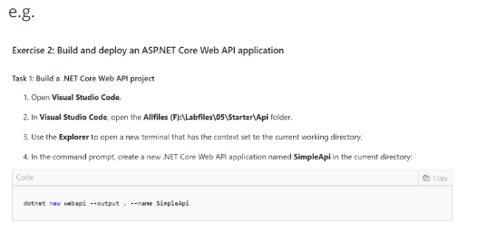

Try this, and hopefully this will enhance your skill level with Azure Development.

Since this is a Microsoft supported GitHub repository, I can't help debug any issues. But it should help you learn the topic.

* + 1. **Processed and Transformed Data Retrieval on to Screen**

Although the display logic can be simple, the Calculations and Business rules to process the data can sometimes increase the complexity level.

1. **New AZ-203 Virtual Machines**

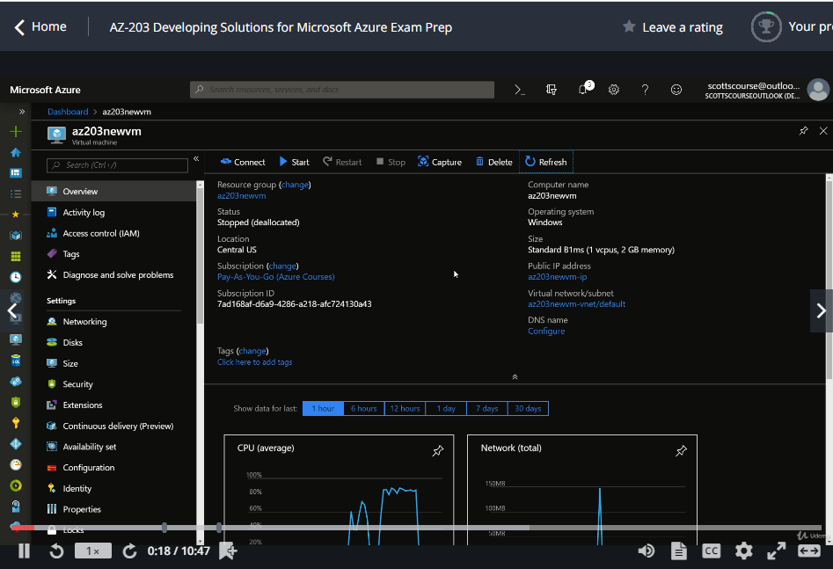

If VM start and you are not using it, then better to stop it, because it charged based on the usage.

In order to create new VM 🡪 Click Create a Resource 🡪 Click on Compute 🡪 Click Windows Server 2016 Datacenter or Virtual Machine

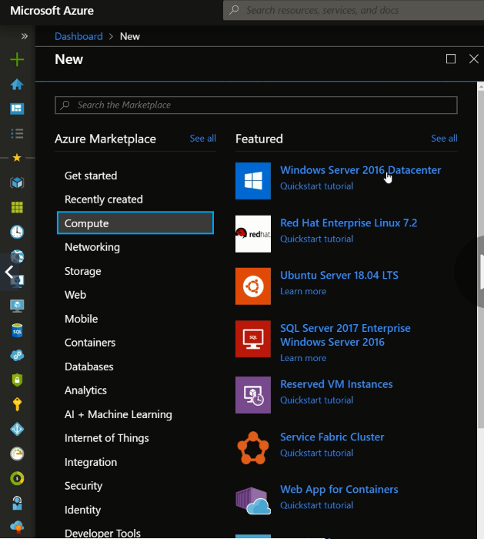

1. **Encrypt a VM**

How to encrypt an operating system in data disk with any VM?

File and storage account already encrypted which is called secure storage account.

First you need Key Vault – is a Microsoft product, is a secure key management is essential to protecting data in the cloud. With Azure Key Vault, you can safeguard encryption keys and application secrets like passwords using keys stored in hardware security modules (HSMs)

**Enhance data protection and compliance**

**Boost performance and achieve global scale**

Click Create a Resource 🡪 Search Key Vault 🡪 Create

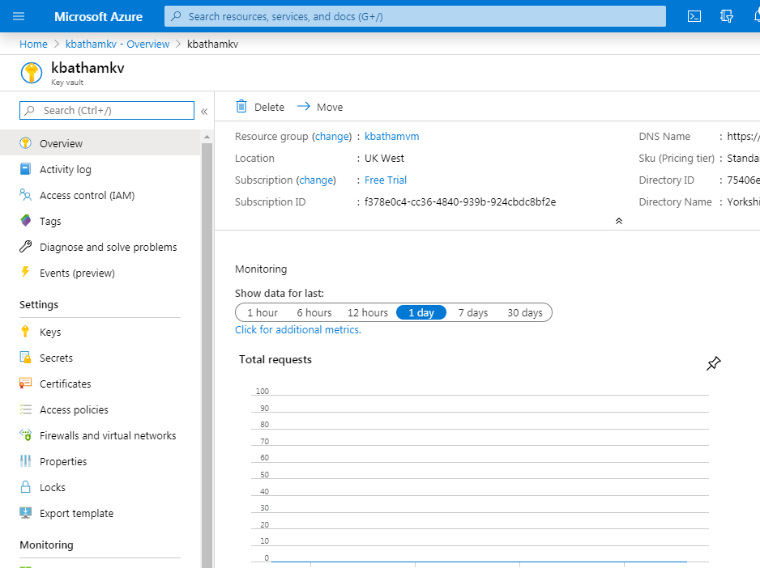

Key Vault allow you to create keys, secrets and certificates

Key Vault should be in same region as you VM is. You can only do encryption on VM standard Standard DS1 v2 or above

Create a VM as below 🡪 it is default un-encrypted VM

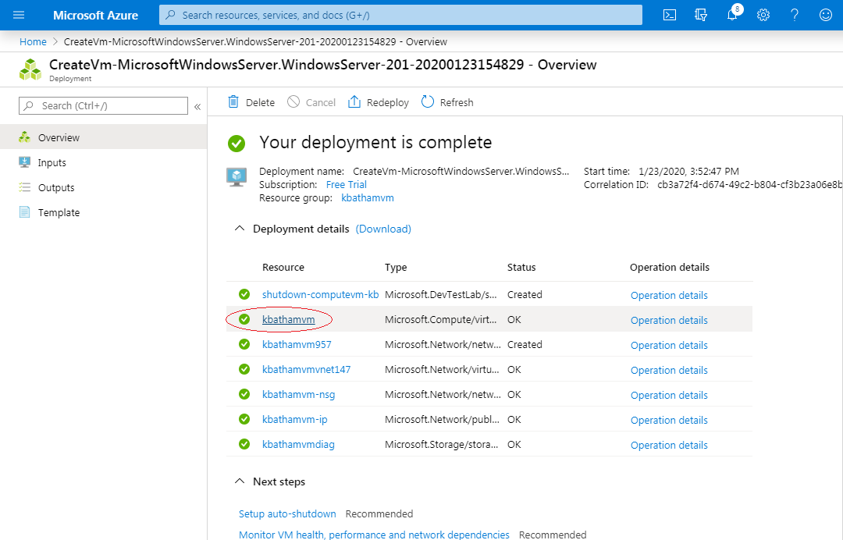

Now want to encrypt up-running disk 🡪 Click kbathamvm 🡪 Click on Disk in Left Panel

You will see that it is not enabled

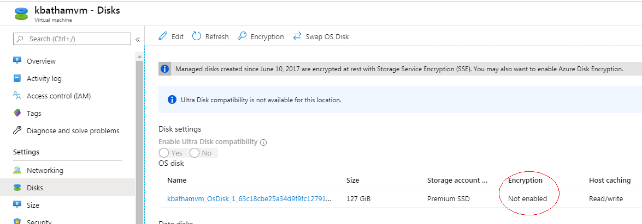

Now we want to enable the encryption 🡪 To do this use PowerShell (Click > icon behind the search on top menu)

So we are going to use PowerShell to encrypt the VM go to below link

<https://docs.microsoft.com/en-us/azure/virtual-machines/windows/encrypt-disks>

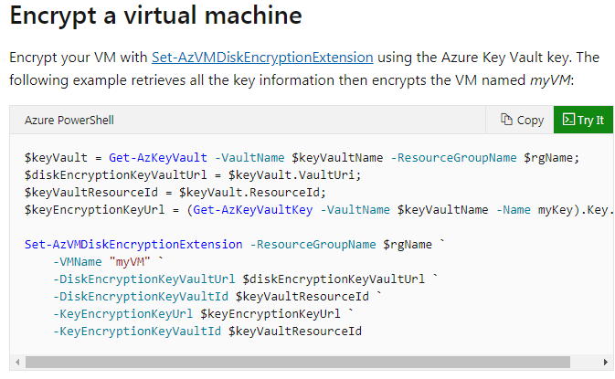

**Copy the command into text editor and change the paremeter**

* $keyVault = Get-AzKeyVault -VaultName "kbathamkeyvault" -ResourceGroupName "kbathamkvrg";
* $diskEncryptionKeyVaultUrl = $keyVault.VaultUri;
* $keyVaultResourceId = $keyVault.ResourceId;
* $keyEncryptionKeyUrl = (Get-AzKeyVaultKey -VaultName "kbathamkeyvault" -Name "kbathamdiskencryption").Key.kid;
* Set-AzVMDiskEncryptionExtension -ResourceGroupName "kbathamvm" `

-VMName "kbathamvm" `

-DiskEncryptionKeyVaultUrl $diskEncryptionKeyVaultUrl `

-DiskEncryptionKeyVaultId $keyVaultResourceId `

-KeyEncryptionKeyUrl $keyEncryptionKeyUrl `

-KeyEncryptionKeyVaultId $keyVaultResourceId

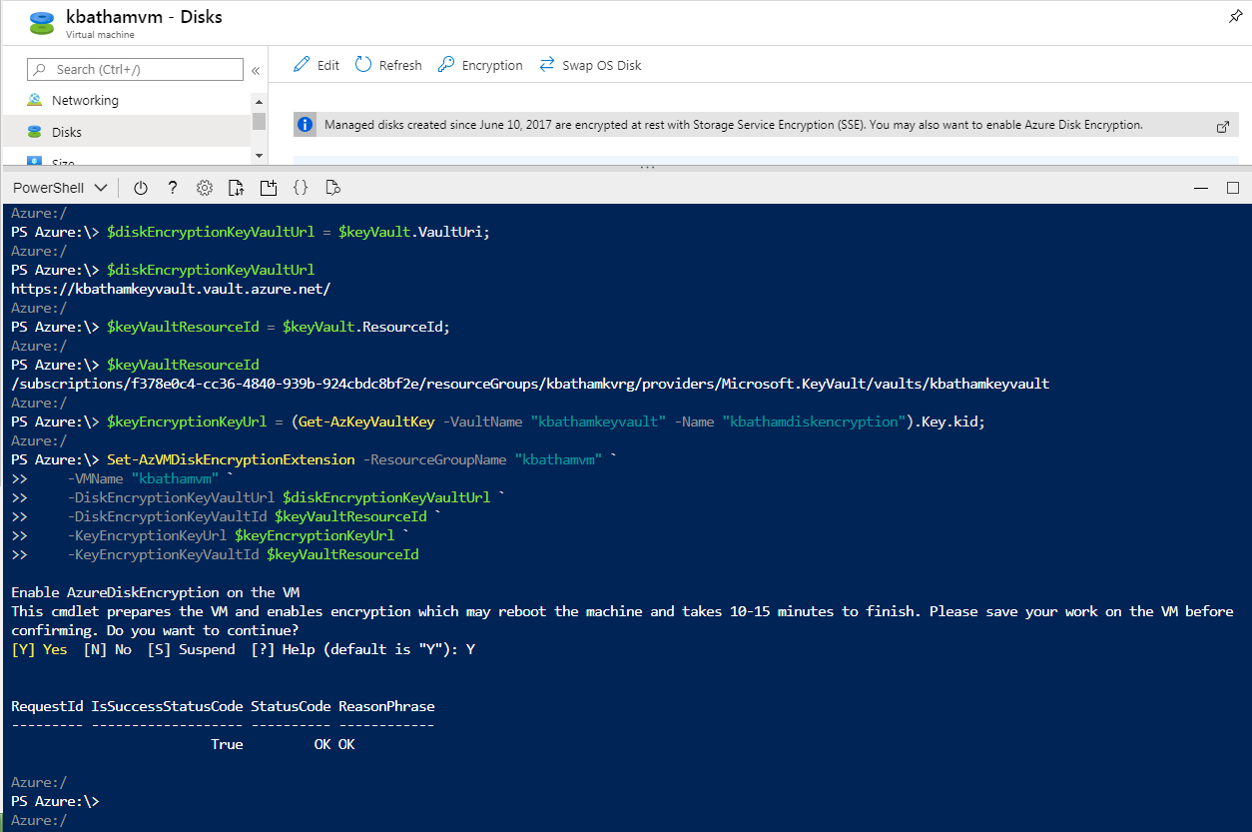

**Now you will see the encryption enabled**

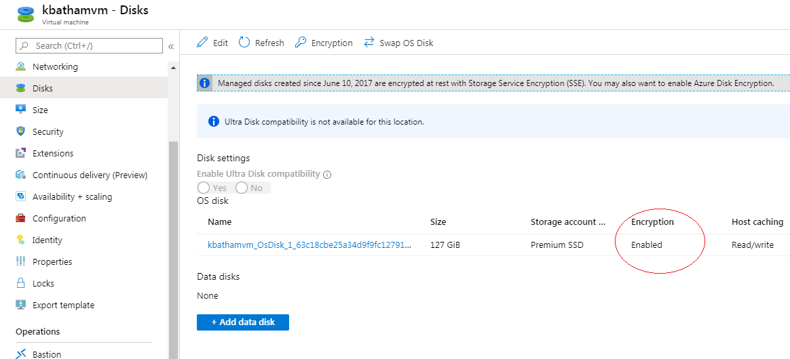

**Questions:**

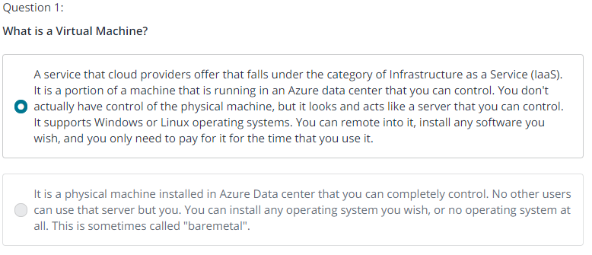

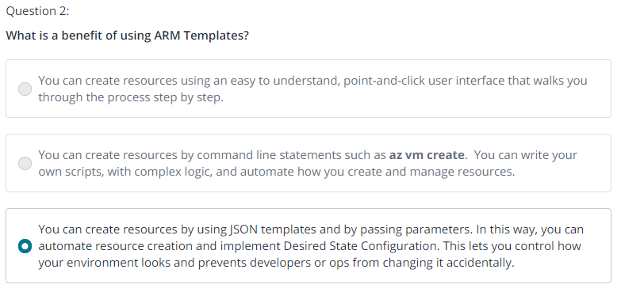

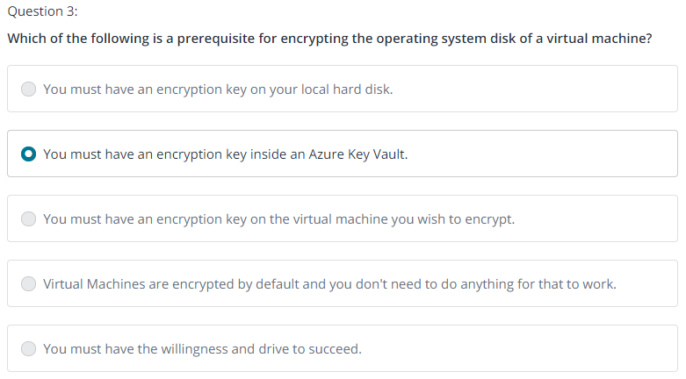

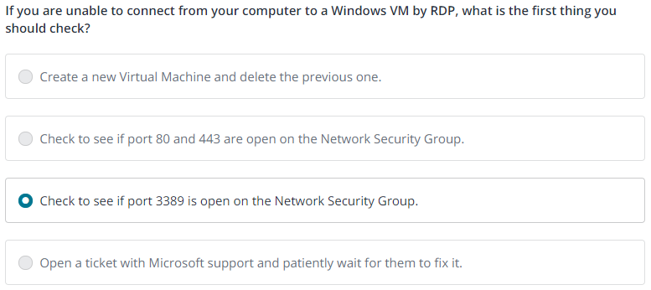

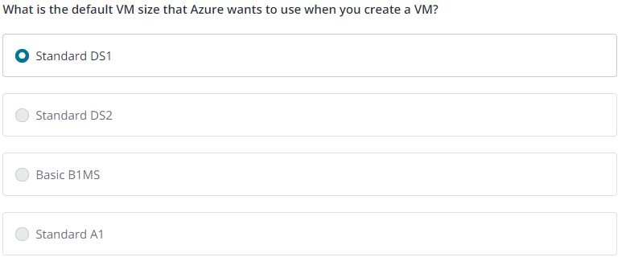

1. **Azure Batch Services**

**Allows you to upload the batch jobs into cloud and Azure manage the execution. Batch jobs keep running for some kind of information, example weather prediction, rendering movies.**

Microsoft Azure Batch is fully-managed cloud services that provides job scheduling and compute resource management for developers in organizations, independent software vendors, and cloud service providers. Both new and existing high performance computing (HPC) applications running on workstations and clusters today can be readily enabled to run in Azure at scale, and with no on-premises infrastructure required. Common application workloads include image and video rendering, media transcoding, engineering simulations, Monte Carlo simulations, and software test execution, among others; all highly parallel, computationally intensive workloads that can be broken into individual tasks for execution. With Azure Batch, you can scale from a few VMs, up to tens of thousands of VMs, and run the largest, most resource-intensive workloads.

**Batch service require a Batch account – So create a new Batch account**

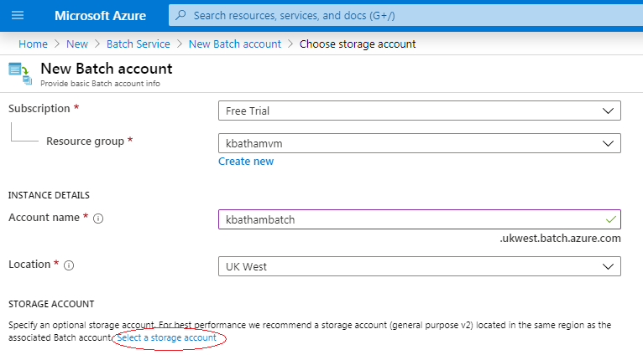

**Finally created new storage account 🡪 Move next 🡪 Create your Batch Account**

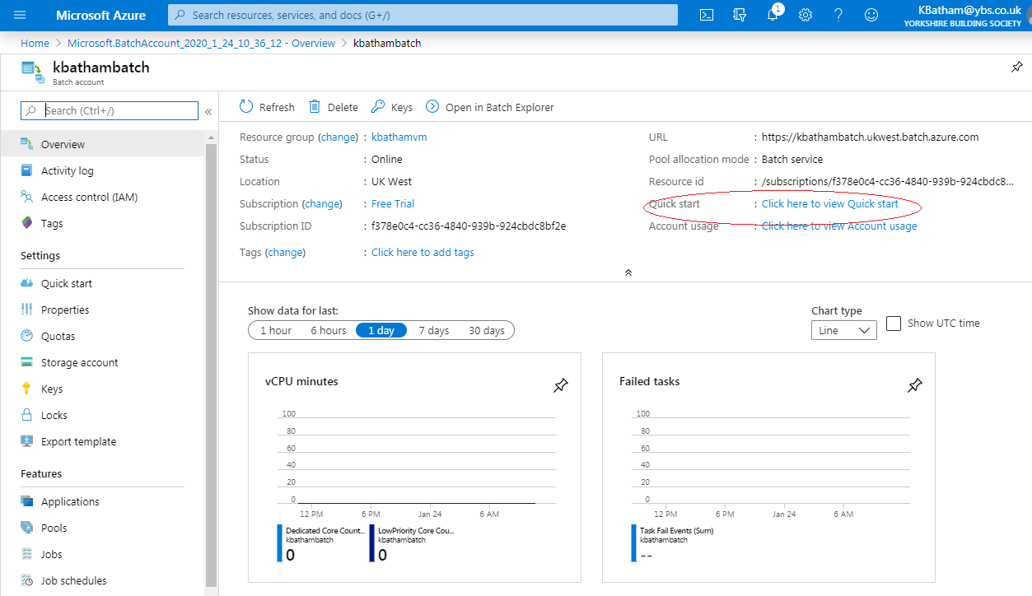

**Click on View Quick Start 🡪 Click On Microsoft Azure Batch Sample Code**

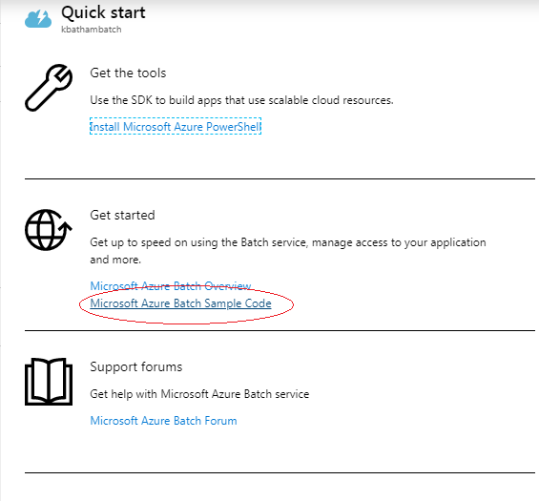

**You will redirect to GitHub Page 🡪** <https://github.com/Azure-Samples/azure-batch-samples>

This contains the sample code for Azure Batch 🡪 Go To C# directory

For Practice 🡪 Click on GettingStarted 🡪 Hello Word 🡪 See the coding in Program.cs

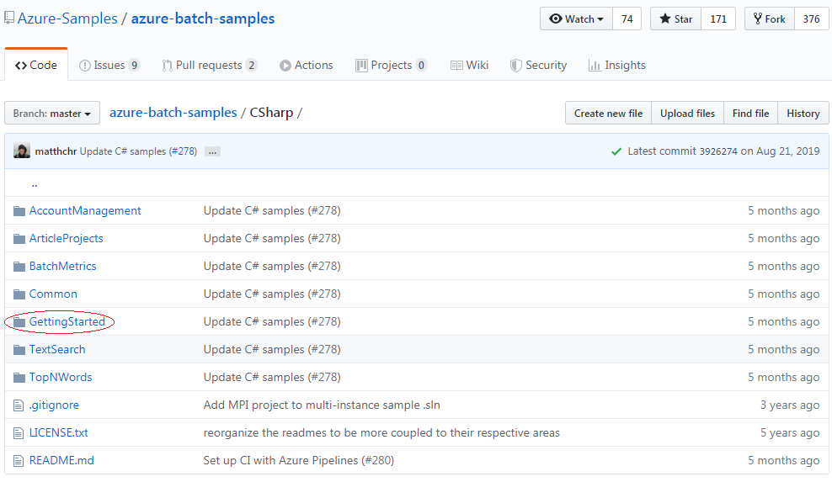

Download all files 🡪 go to Hello Word 🡪 Open in Visual Studio

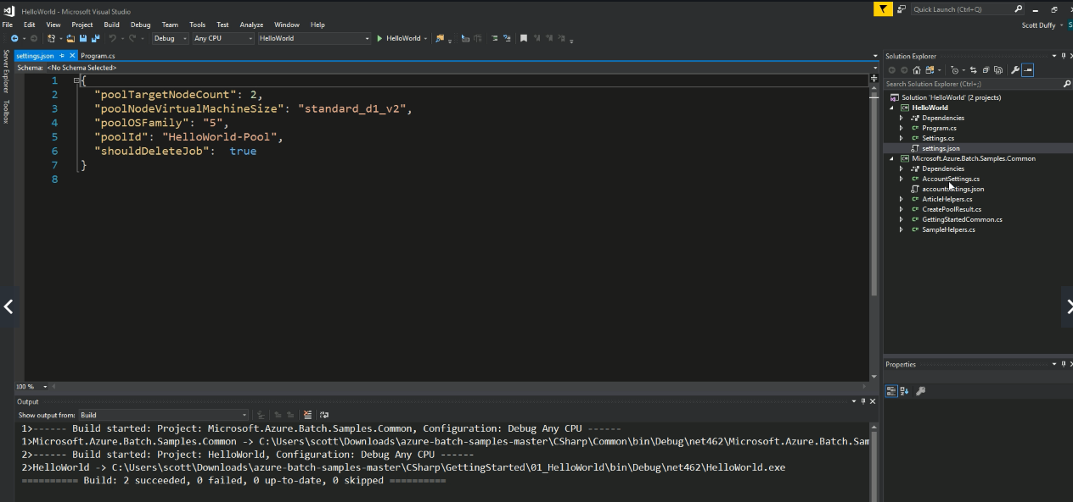

Now you can see the settings.json that contains some job specific settings

Now there is an accountsettings.json as below

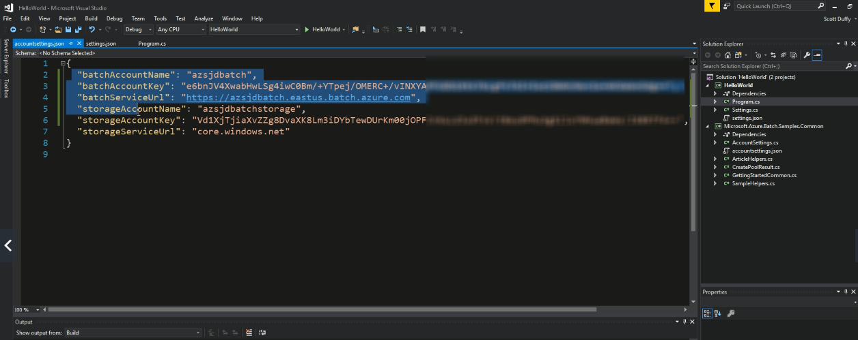

Go to Azure portal and define your value in above fields that created in Batch Service Account

Build project again 🡪 Hit F5 to run the project 🡪 Its fail in function LoadAccountSettings() 🡪 To fix it copy the accountsettings.json file from Common project to HelloWord Project

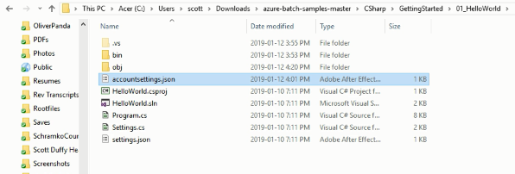

Run again 🡪 It will load the value from accountsetting.json and kick-off the job in Async way and uploading the job in Batch Account.

Go to your Batch Account

If you want to open it on Batch Explorer 🡪 download the software and Install

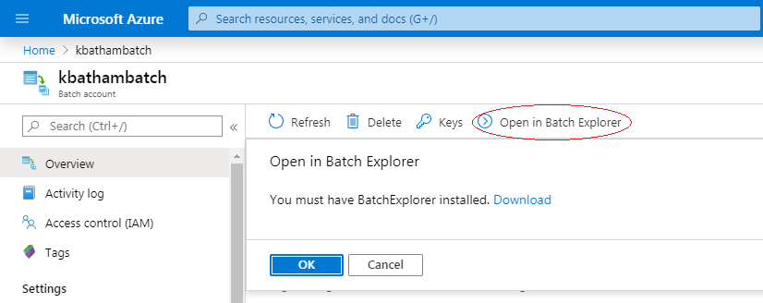

Here in Batch Explorer 🡪 you can see what’s going on in batch, this tool really helpful for the complicated job for monitoring

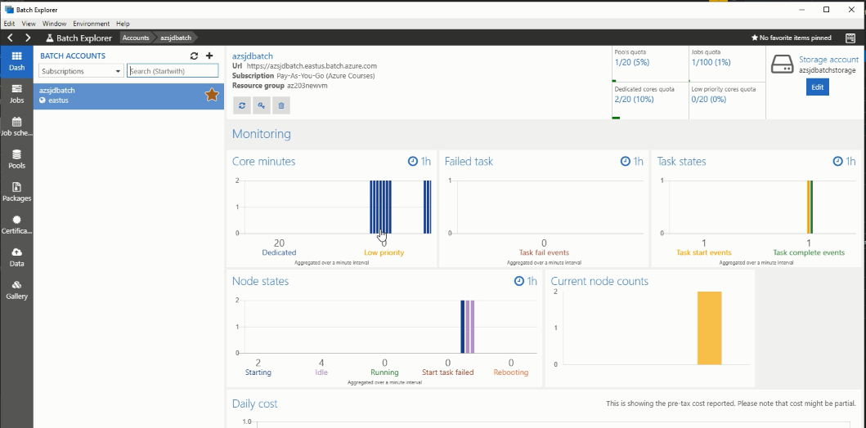

* 1. **Code Samples: Azure Batch**

Since the AZ-203 exam will want you to develop for Azure Batch, here is a relevant Getting Started Github project:

<https://github.com/Azure-Samples/batch-dotnet-manage-batch-accounts>

1. **New AZ-203 Containerized Solution**

Container is short of mid-way point between a purely infrastructure as a service (IAAS) and VM solution or controlled environment or PASS environment

* 1. **Azure Kubernetes Services Cluster:**

Azure Kubernetes Service (AKS) manages your hosted Kubernetes environment, making it quick and easy to deploy and manage containerized applications without container orchestration expertise. It also eliminates the burden of ongoing operations and maintenance by provisioning, upgrading, and scaling resources on demand, without taking your applications offline.

**It packages your code and package self-contained all of the dependency everything that need to run and deploy your code as a package into Azure.**

**So it’s kind of container for all your deployment, so you can pull the container out of container repository, and it has everything you need for deployment.**

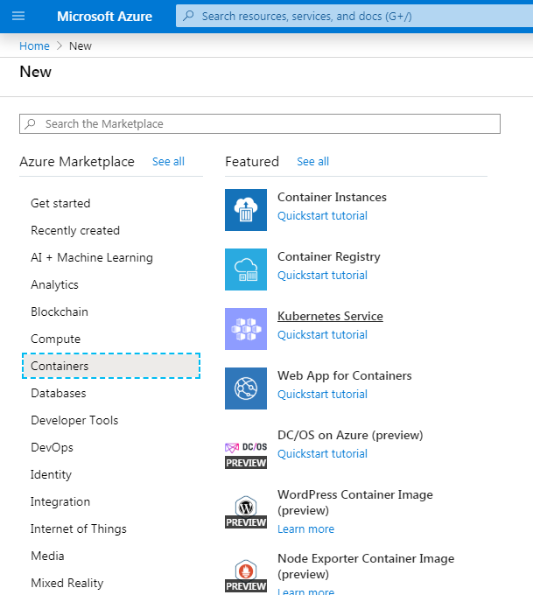

Create a newKubernetes Service 🡪

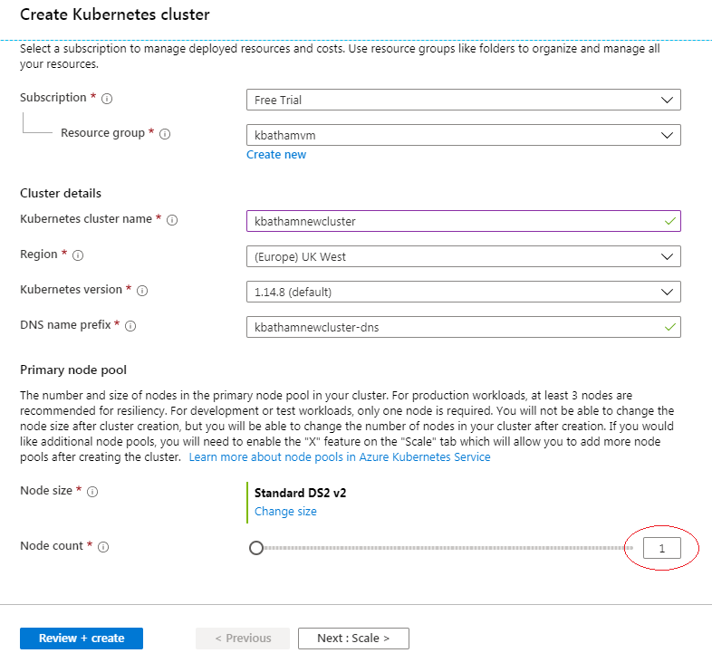

* 1. **Deploy AKS Cluster**

In order to connect this cluster, we use command line to connect this cluster. 🡪 In last demo we have use powershell

Not try to switch to Azure CLI

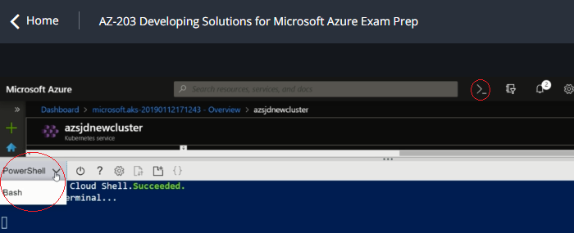

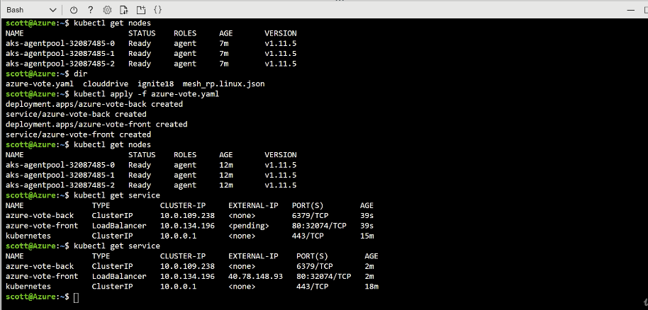

* 1. **Browse ASK Dashboard**

First download and install Azure CLI on Windows

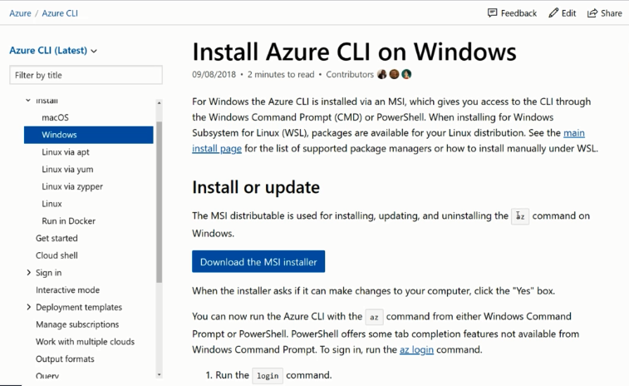

Go to View Kubernetes Dashboard

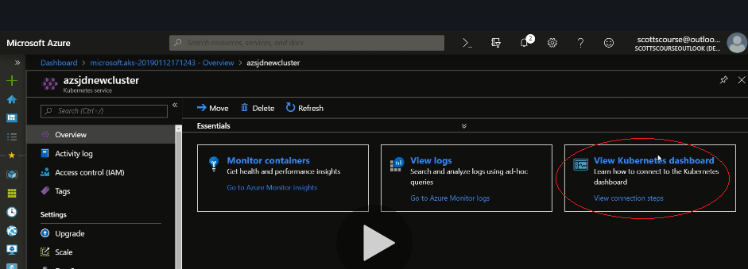

And Run the commands in Powershell

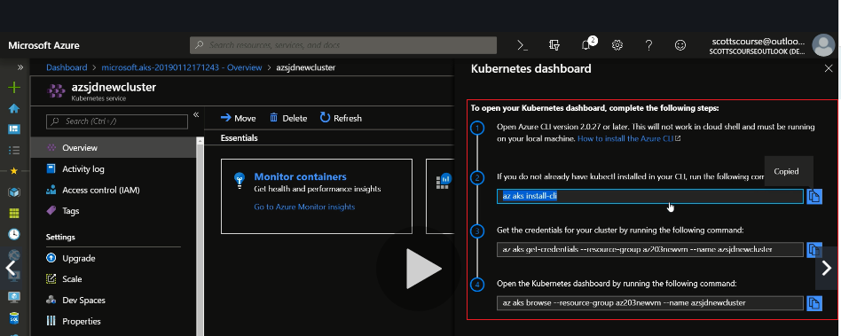

Final command will fire up a webserver 🡪 A dashboard

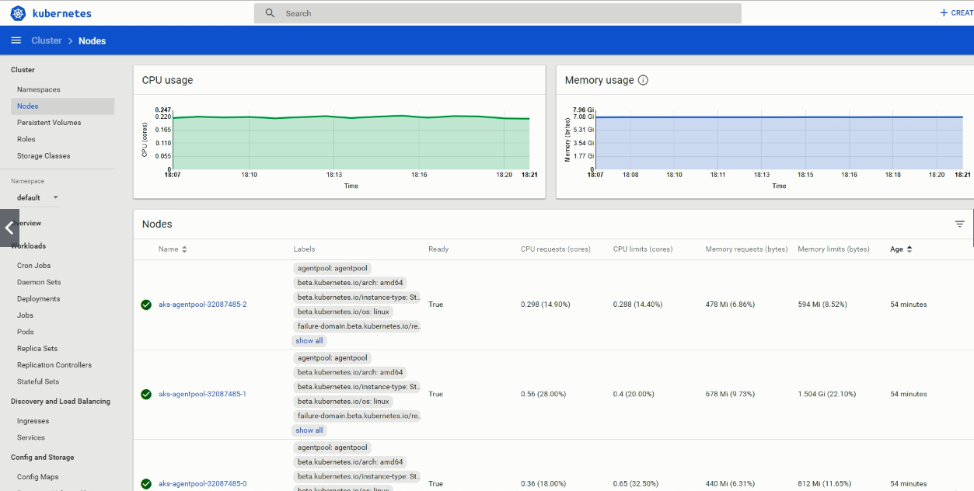

1. **Introduction to App Service**

Azure App Service is an HTTP-based service for hosting web applications, REST APIs, and mobile back ends. You can develop code in local machine and publish it on web app. Microsoft Azure take care to running the web app. Applications run and scale with ease on both Windows and Linux-based environments.

Azure web app called the Azure App service

Azure App service only supports .Net, .Net core, Java, Ruby, Node.js, PHP, or Python

Go and create new App Service 🡪

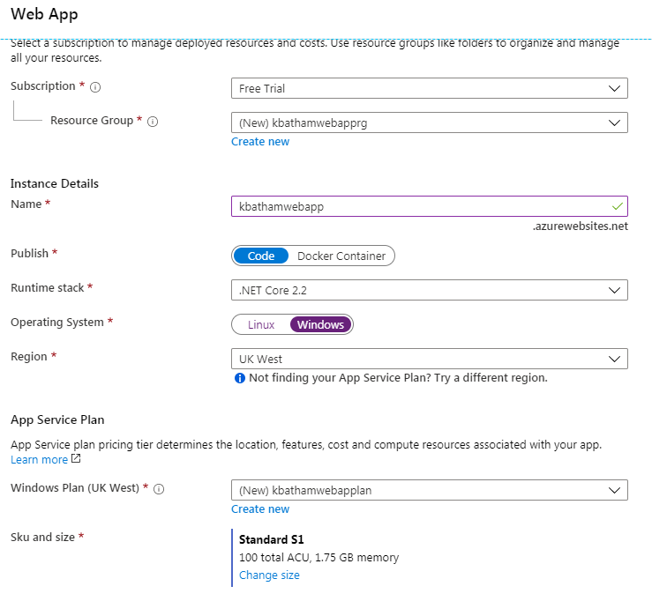

Web App is public by default, therefore, it given full qualified name

* 1. **App Service Plan**

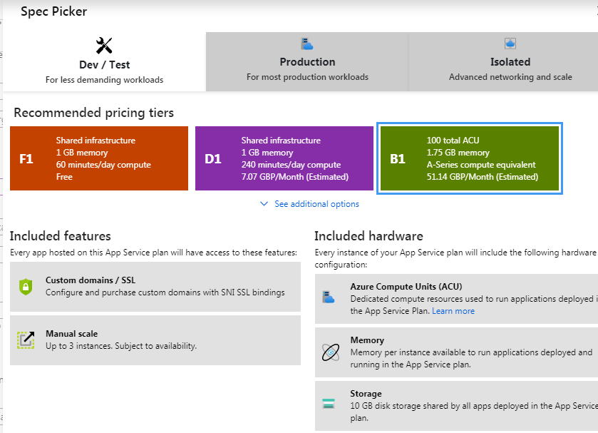

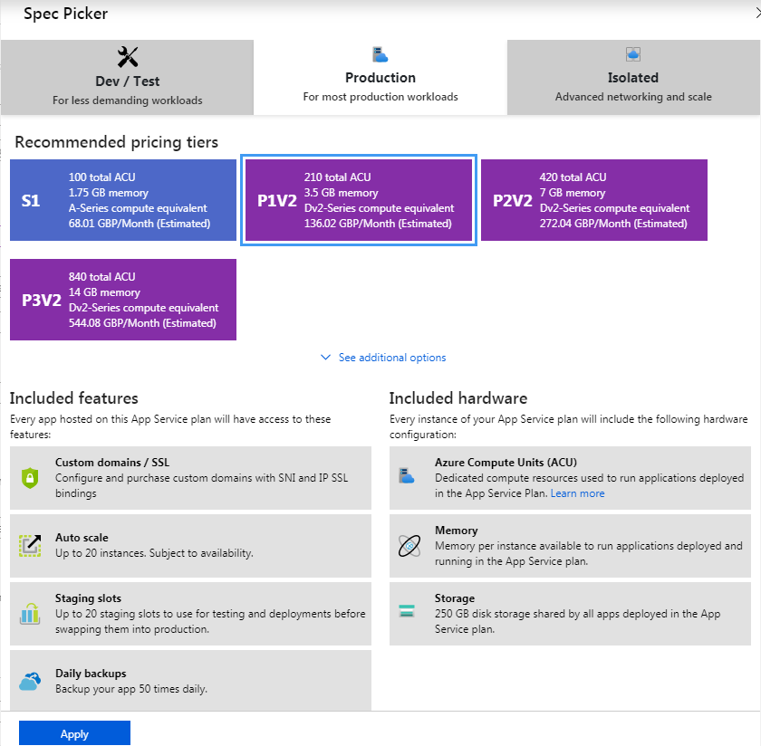

Isolation plan available for someone, who doesn’t want any other user or tenant running on the same hardware, you can use Isolation.

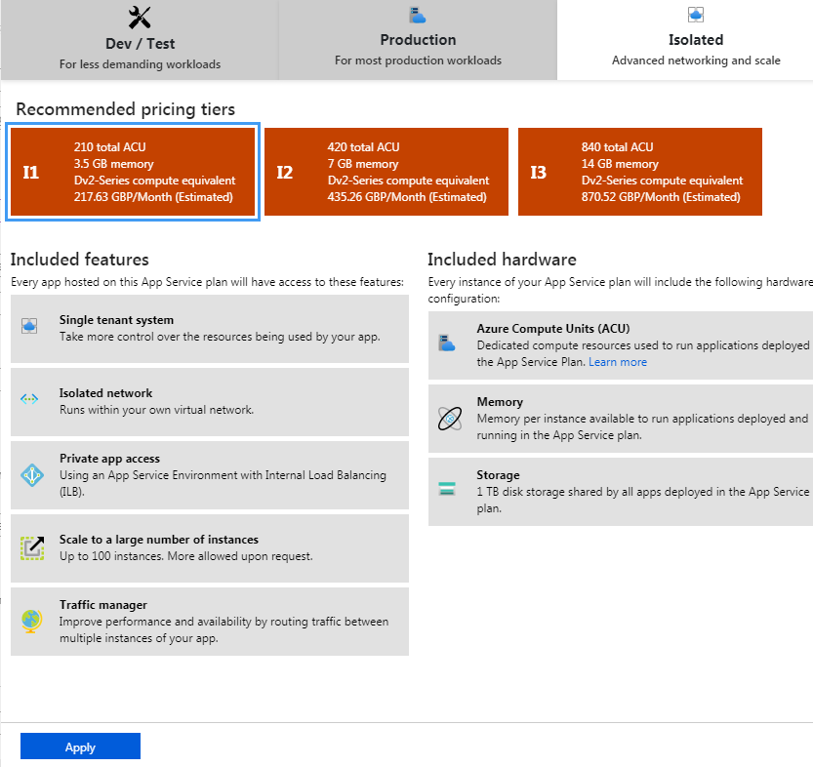

Choose appropriate SKU and Size, Finally create a new WebApp,

Its running but we didn’t deploy any code.

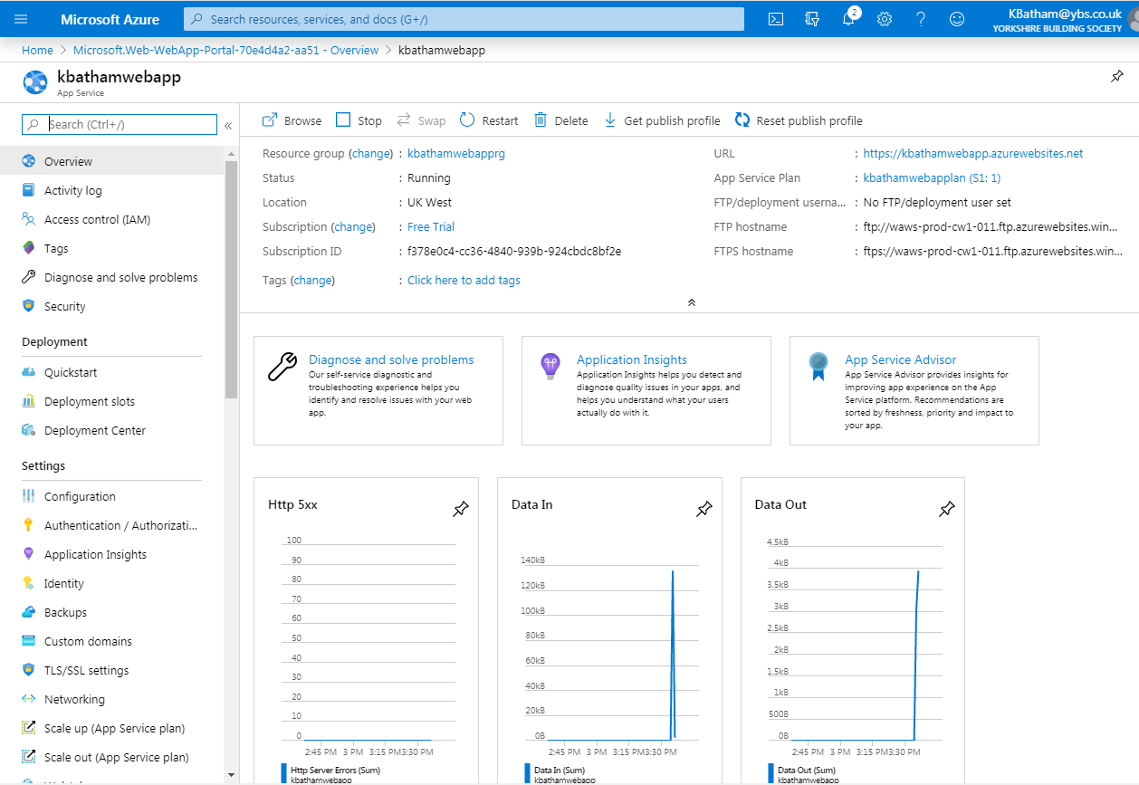

* 1. **Custom Domain**

You can add custom domain, so that instead of your web app running on URL as shown below

<https://kbathamwebapp.azurewebsites.net>

You can set it as

https://kbathamwebapp.ybs.com

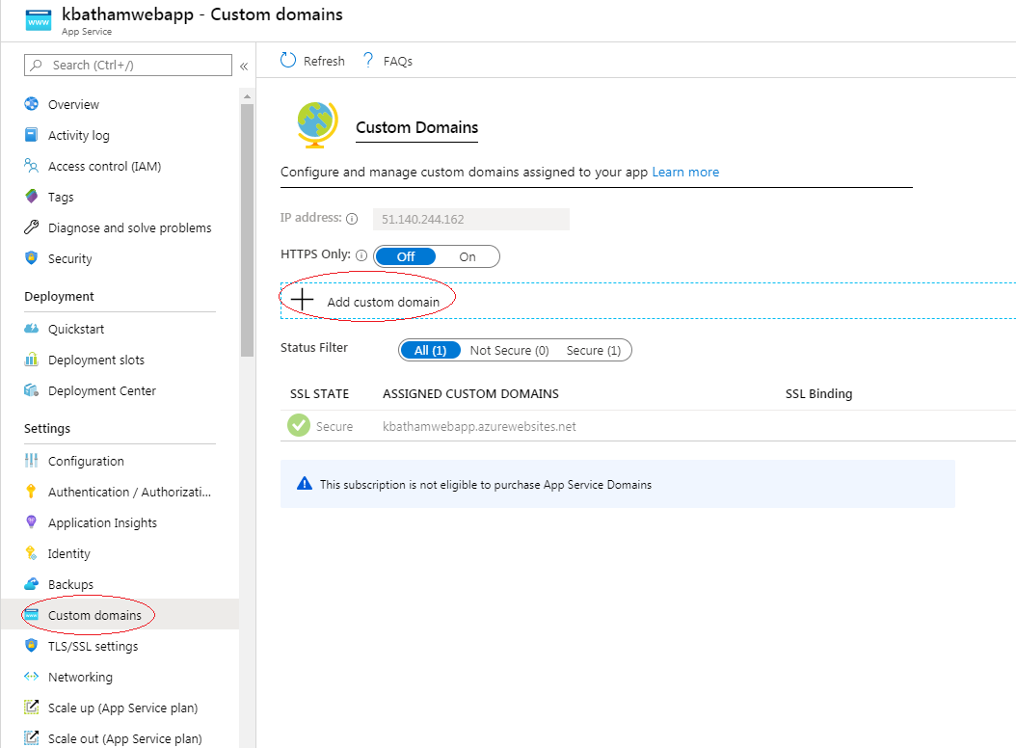

You have lot of options for application related settings

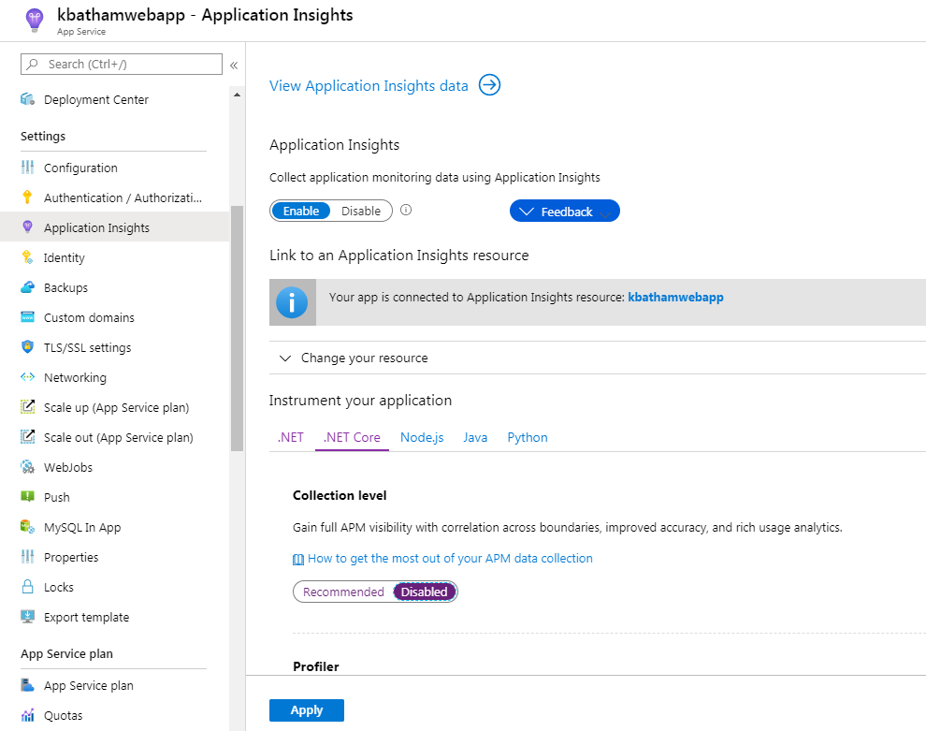

So you package and upload the code in Azure, and Azure will run that within App service plan. It does take to visiting the URL (<https://kbathamwebapp.azurewebsites.net>) for website to run.

So if you upload your code in Web App and no one visit your URL that code will never run.

Option to run it independently instead somebody visit or not 🡪 Called Web Jobs

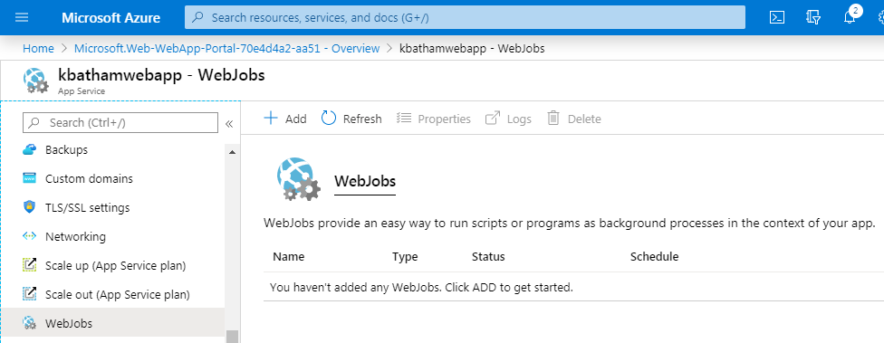

Web jobs provide easy way to run program as background process.

So, Click Add button and Add web job, Give the path of the file that will run as job

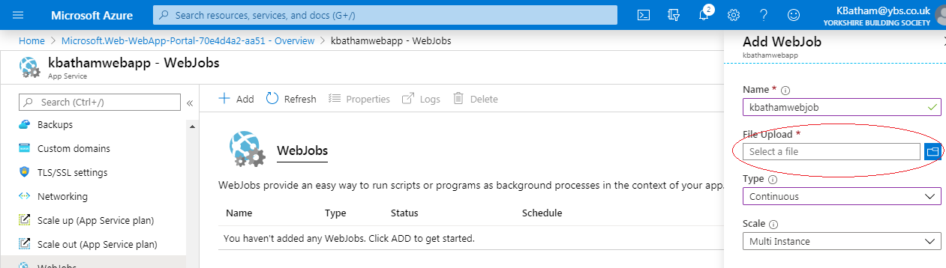

* 1. **Enable Diagnostic Logs**

You can enable log by clicking on App Service Logs. For example, if you want Application logging (Blob) as shown below.

You have to define storage settings.

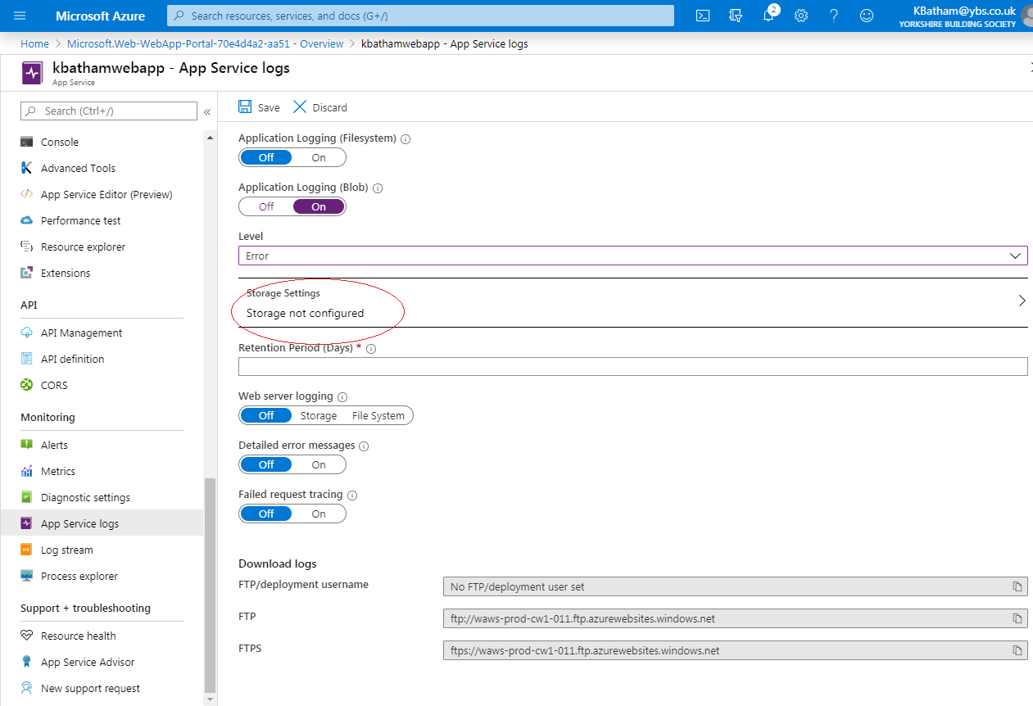

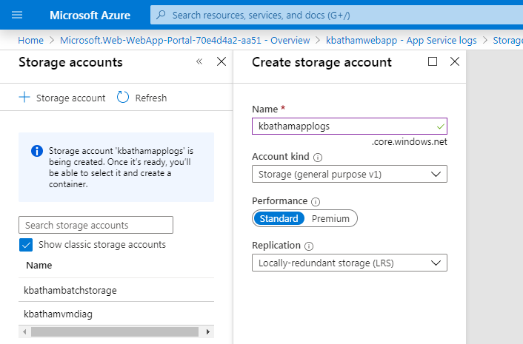

You can set the web server logs 🡪 like IIS logs and other

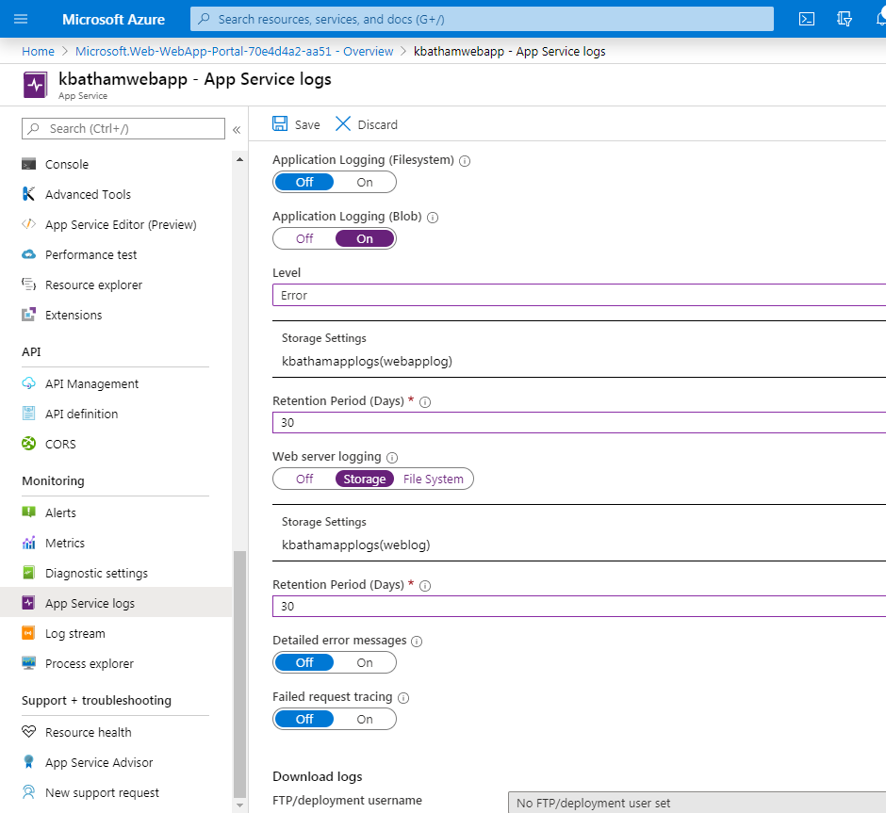

## Finally to see the logs 🡪 go to All Resource 🡪 Select kbathamapplogs 🡪 Storage Explorer

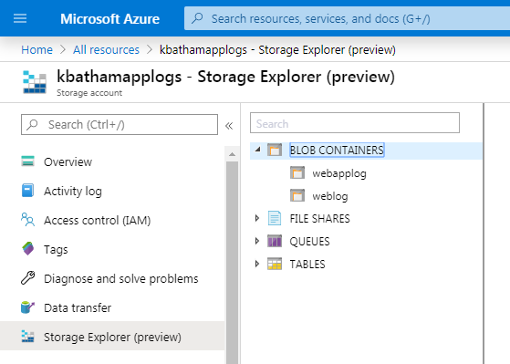

You can see the logs

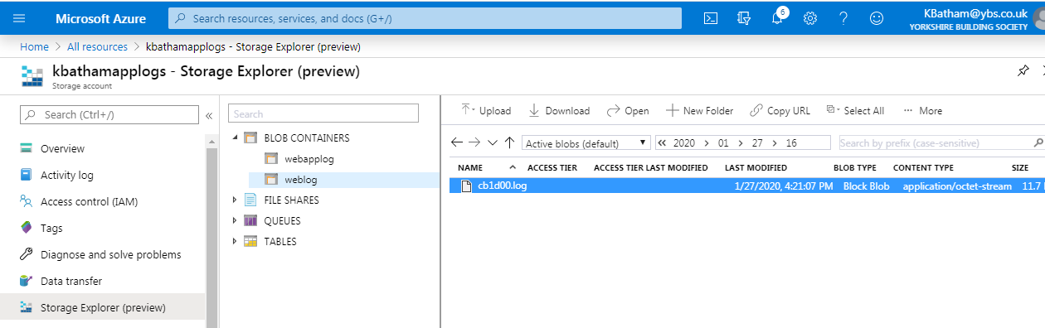

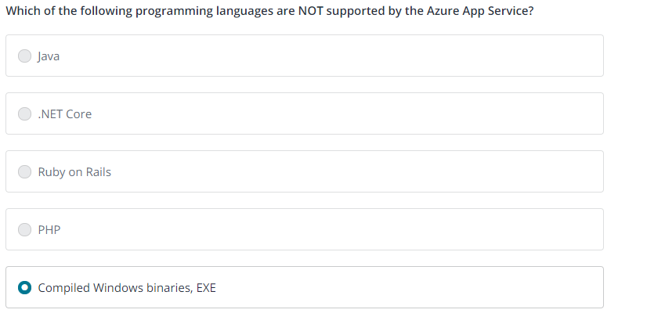

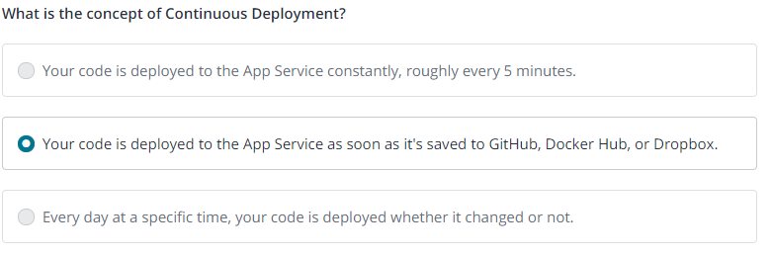

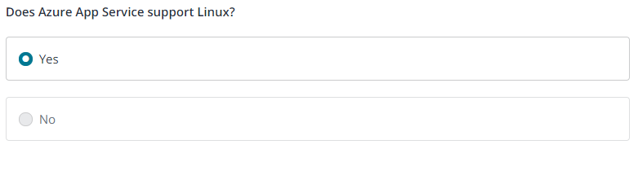

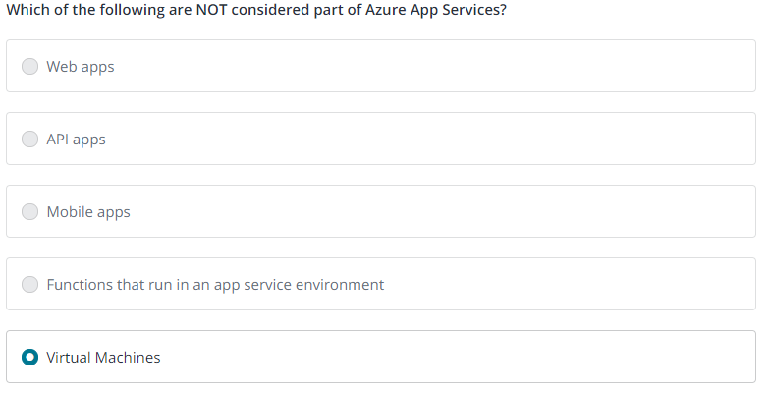

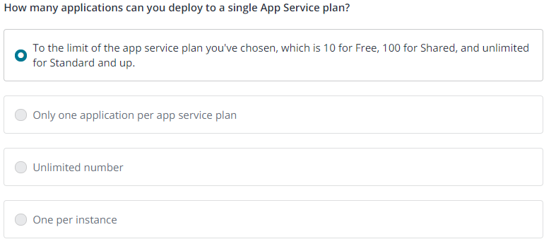

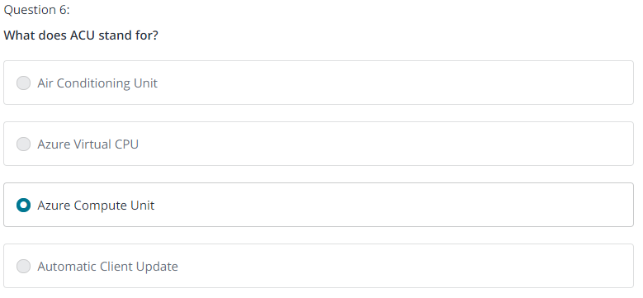

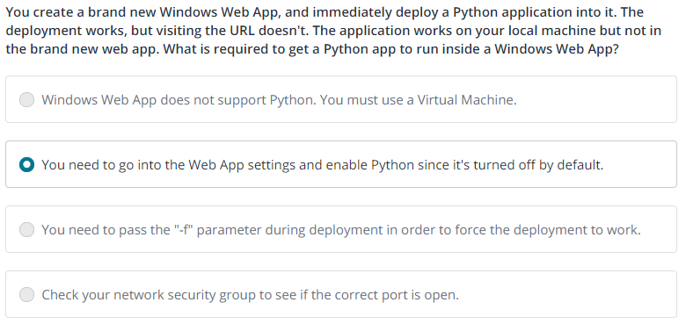

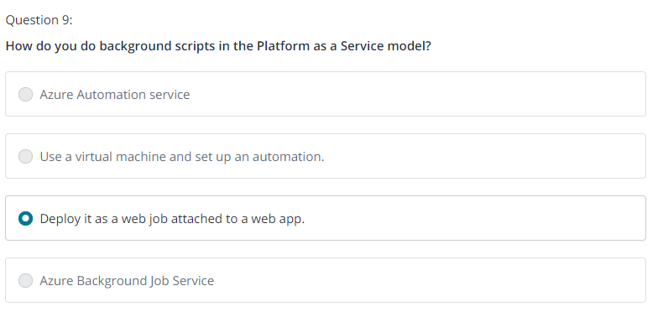

**Code Samples: App Service:** Since the AZ-203 exam will want you to develop for App Services, here is a relevant Getting Started Github project:

<https://github.com/Azure-Samples/app-service-web-dotnet-get-started>

1. **New AZ-203 Mobile Apps**

In the last section, in app service when taking about web apps, mobile app or API apps are pretty much same things under the cover with different icon and name

People often associate Mobile apps with push notification, offline synchronisation and all. Apps running on your phone need to talk to your database or need to send the log information in backend. So mobile in the cloud is the backend to the presentation layer that running on the phone.

So we taking about mobile app services, notification hub

* 1. **Notification Hub**

Notification hub allows app developers to have fairly easy access to sending notifications to phone, Apple has its own notification system, Android has its own.

Create Notification Hub 🡪

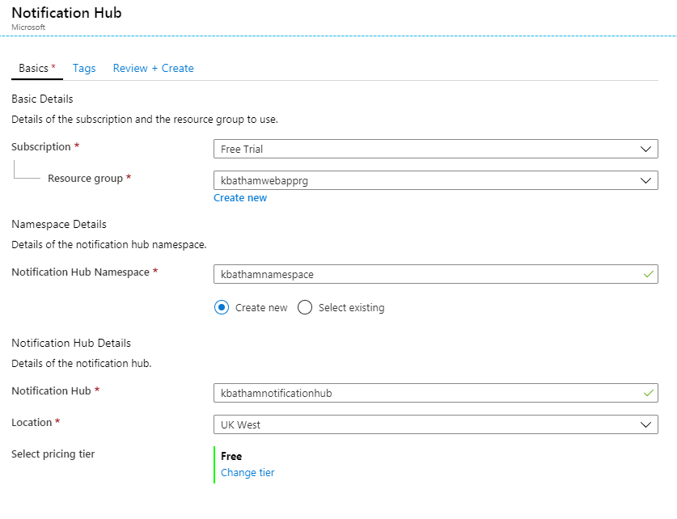

You need to choose pricing

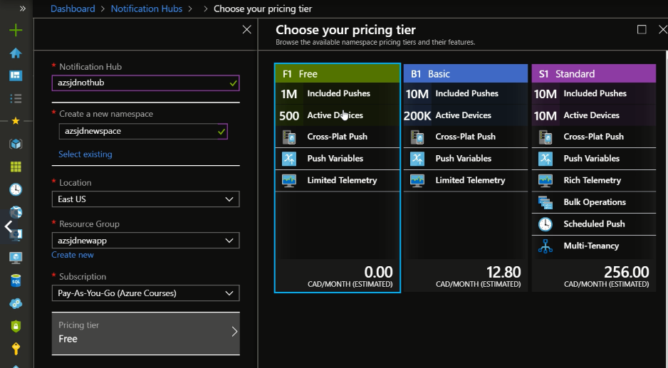

Finally our Notification Hub create 🡪

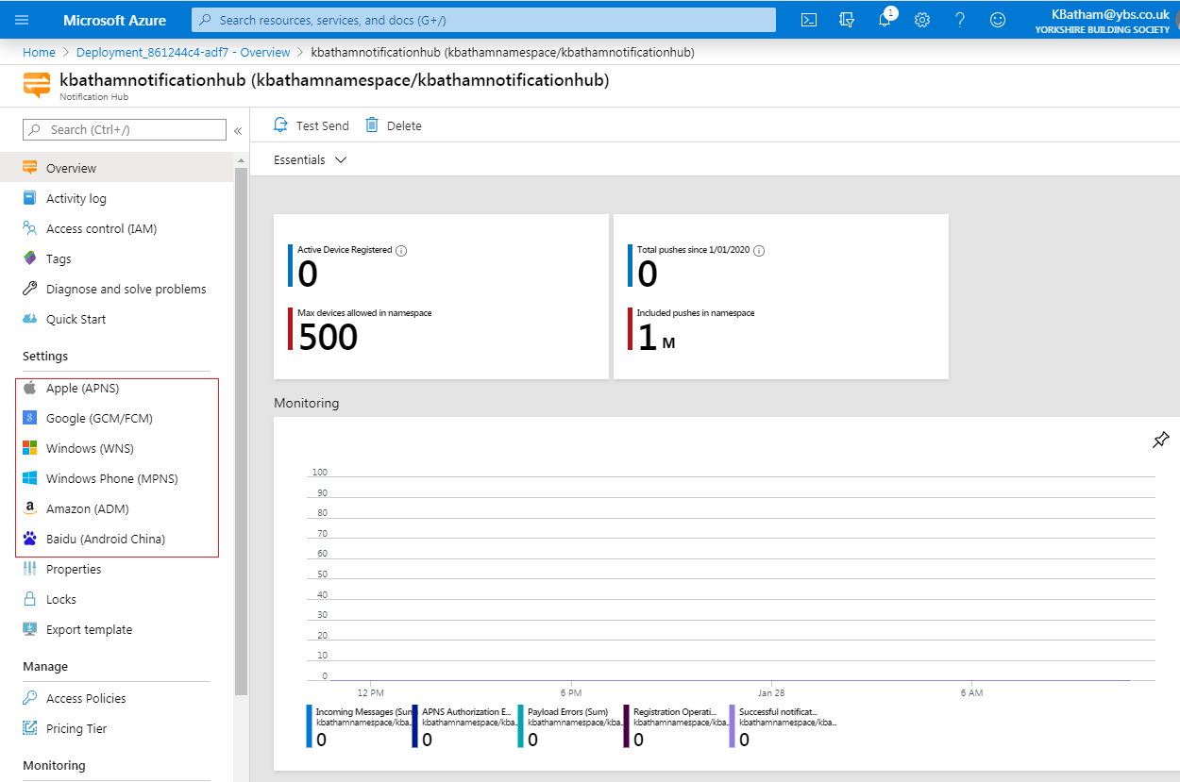

In left you can connect with various notifications service providers.

* 1. **Mobile App**

Create New Mobile App 🡪

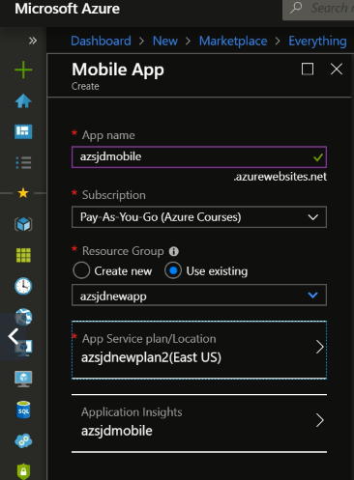

Click Create and Mobile App created 🡪 Scroll down a bit left side menu 🡪 You will set the section Mobile 🡪 We need a database

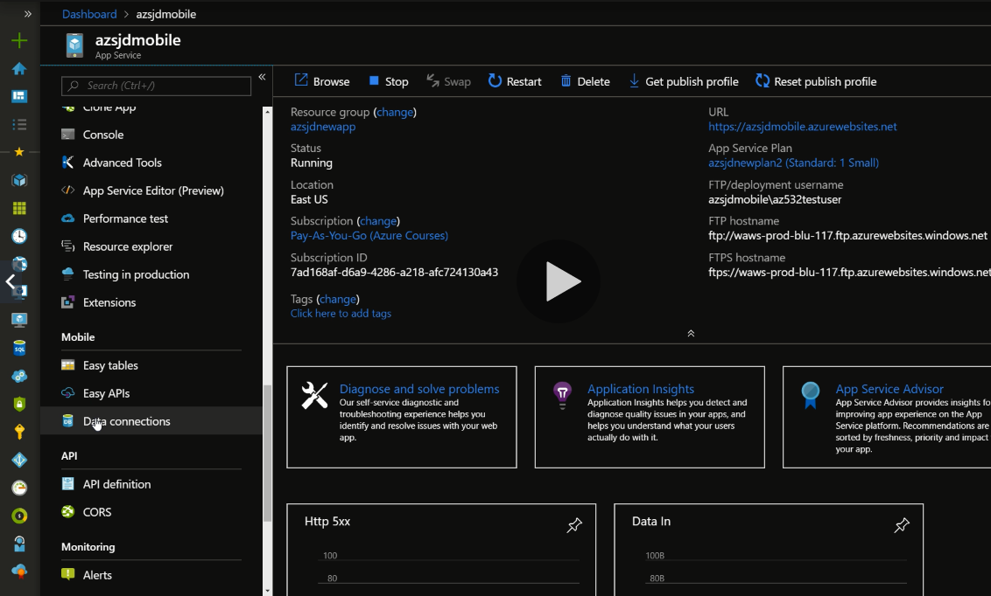

Click on Data connections 🡪 Question how we goanna store this, do we need to store stuff in new SQL database or into storage account

Let’s create a SQL database

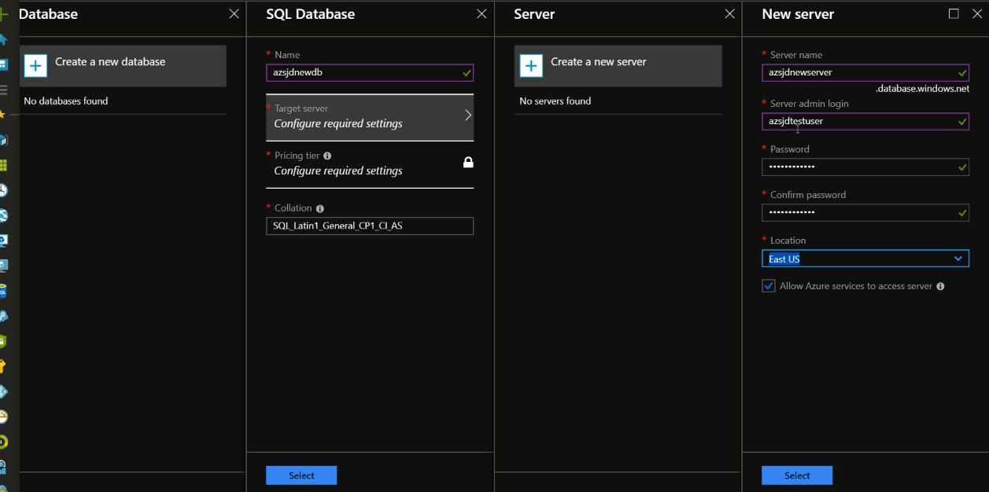

Now we can use this database as backend storage of our Mobile App

* 1. **Code Sample: Notification Hubs**

Since the AZ-203 exam will want you to develop for Event Hubs and Notification Hubs, here is a relevant Getting Started Github project:

<https://github.com/Azure-Samples/event-hubs-dotnet-user-notifications>

1. **New AZ-203 API Apps**

### Create and deploy RESTful APIs in seconds, as powerful as you need them

Leverage your existing tools to create and deploy RESTful APIs without the hassle of managing infrastructure. Microsoft Azure App Service API Apps offers secure and flexible development, deployment, and scaling options for any sized RESTful API application. Use frameworks and templates to create RESTful APIs in seconds. Choose from source control options like TFS, GitHub, and BitBucket. Use any tool or OS to develop your RESTful API with .NET, Java, PHP, Node.js or Python.

* Fastest way to build for the cloud
* Provision and deploy fast
* Simple access control and authentication
* Secure platform that scales automatically
* Great experience for Visual Studio developers with automatic SDK generation
* Open and flexible for everyone
* Monitor, alert, and auto scale (preview)

Create new API Apps 🡪

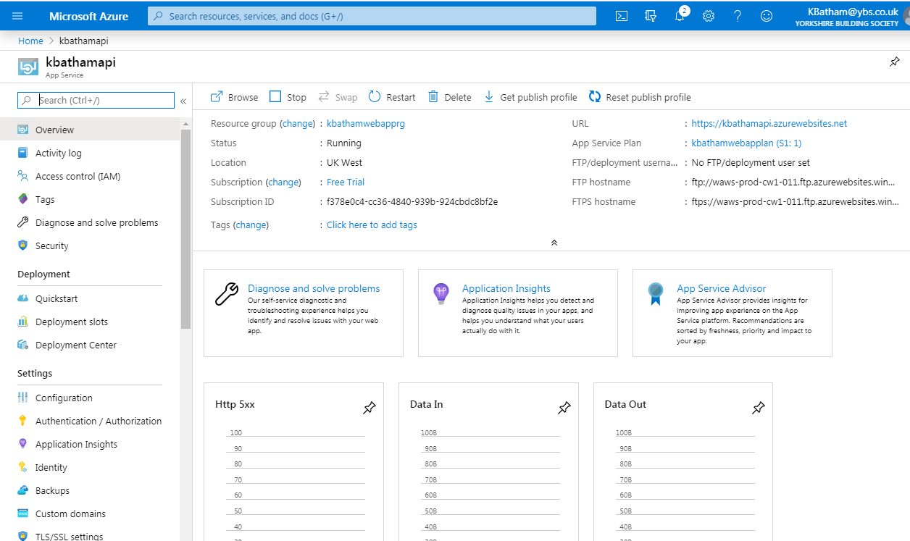

* 1. **CORS**

Cross-Origin Resource Sharing (CORS) allows JavaScript code running in a browser on an external host to interact with your backend. Specify the origins that should be allowed to make cross-origin calls (for example: http://example.com:12345). To allow all, use "*" and remove all other origins from the list. Slashes are not allowed as part of domain or after TLD.

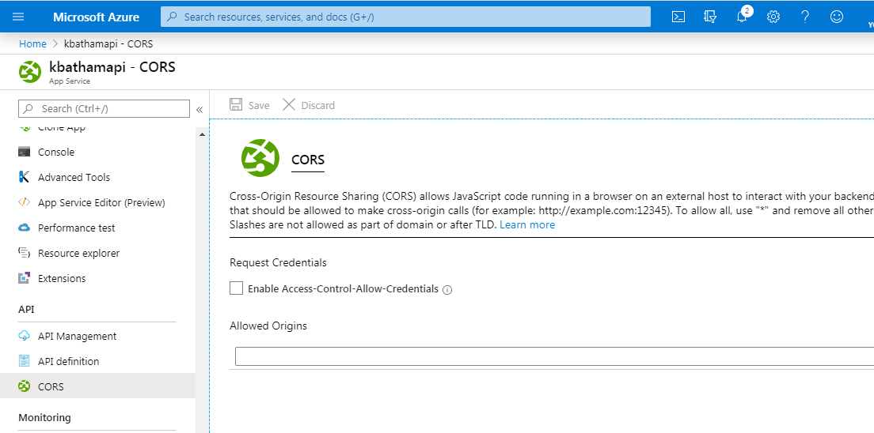

So let’s say I have an API and I know that only application running on<http://example.com> is the only origin that I want to support. 🡪 Than no other website will be able to access my API

If you want that your API can be used by anyone 🡪 than you can add *



* 1. **Demonstration**

To demonstrate these go to GitHub 🡪 Azure-Sample

<https://github.com/Azure-Samples/app-service-api-dotnet-todo-list>

Download the code and Build it

Install –Swashbuckle into your code 🡪 It will allow you to build your API document

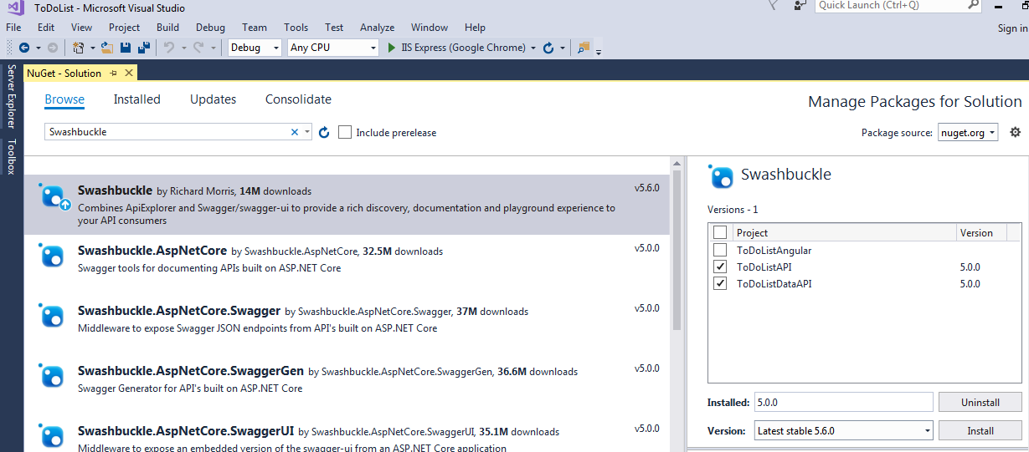

**Now run your application and go to 🡪** <http://localhost:45914/swagger/ui/index>

It basically allows us not only explore the API, even test it real time

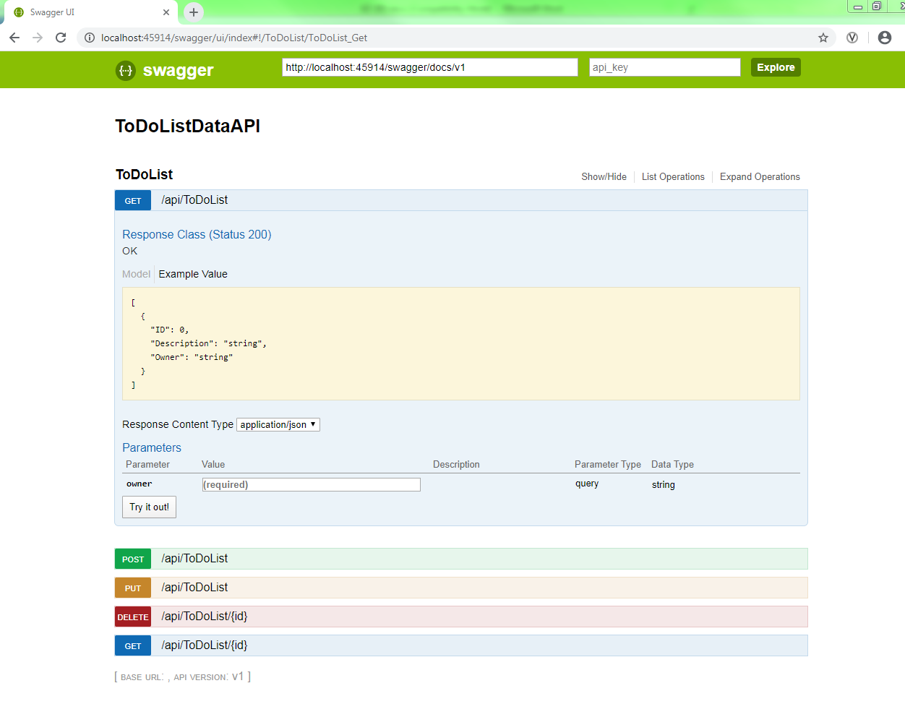

So Swagger is standard of API documentation

Now you can set the API definition as 🡪 url/Swagger (<http://localhost:45914/swagger>)

API definition lets you configure the location of the Swagger 2.0 metadata describing your API. This makes it easy for others to discover and consume your API. Note: the URL can be a relative or absolute path, but must be publicly accessible.

* 1. **Code Sample: API Apps**

Since the AZ-203 exam will want you to develop API Apps, here is a relevant Getting Started Github project:

<https://github.com/Azure-Samples/dotnet-core-api>

This one uses .Net Core. Other samples and languages are available.

1. **New AZ-203 Function App**

Write any function in minutes – whether to run a simple job that cleans up a database or build a more complex architecture. Creating functions is easier than ever before, whatever your chosen OS, platform, or development method.

Create a new Function App

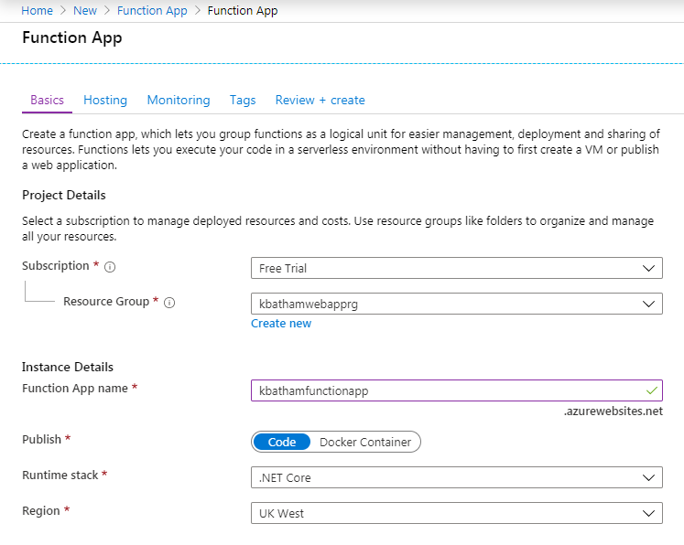

Select your hosting plan 🡪

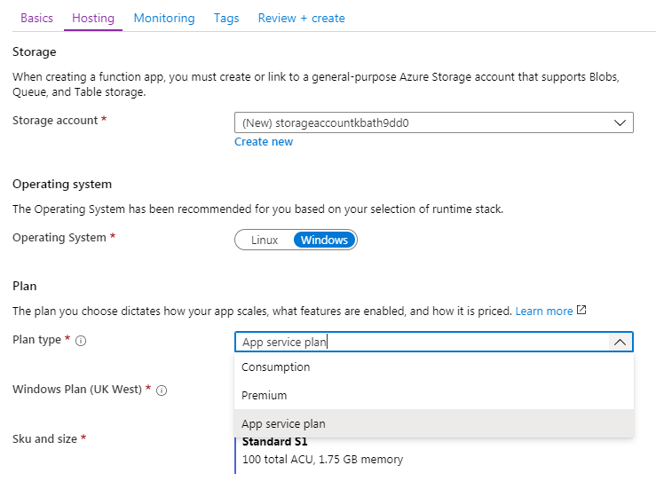

Finally Create Function App 🡪

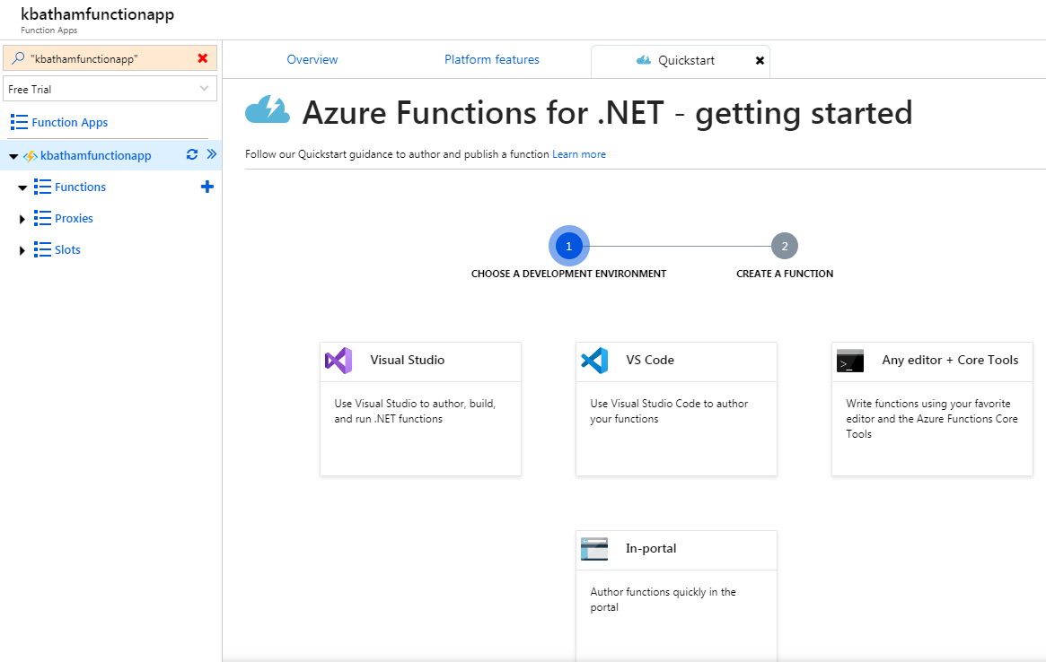

A function is short piece of code that created, develops and tested within the Azure Portal, So unlike the WebApp you develop outside the Azure and upload them and deploy them.

You can create a small function in the portal 🡪 there is no function right now

You have various ways like using visual studio, VS code, Any editor or In-portal by which you can create function. (As shown above)

Let’s see In-portal 🡪 go to More Templates 🡪 you can get many templates to create function

You can see list of multiple templates

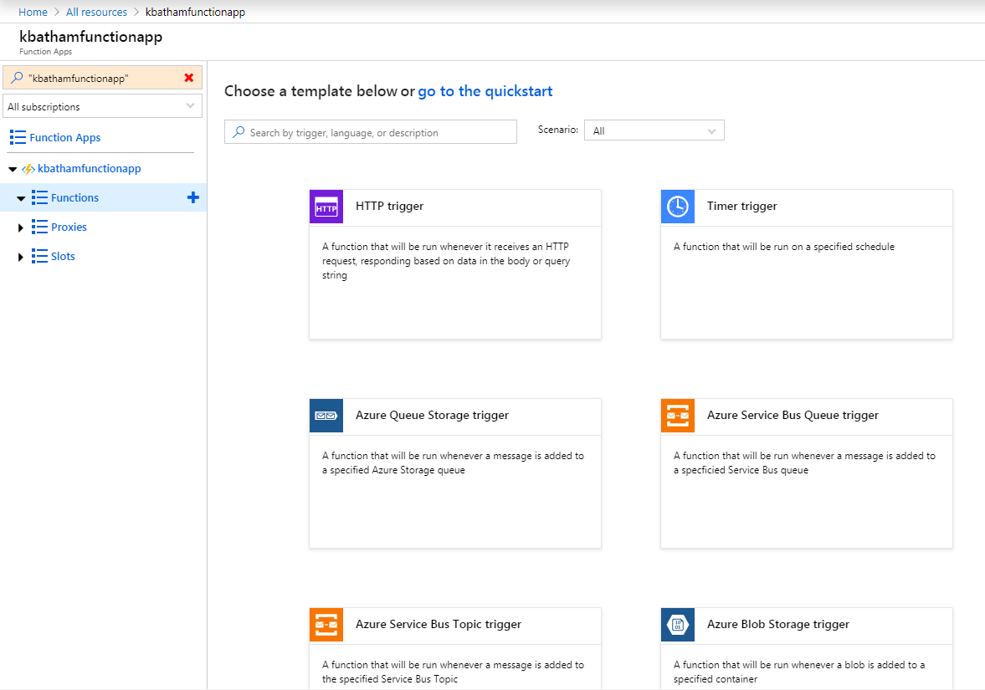

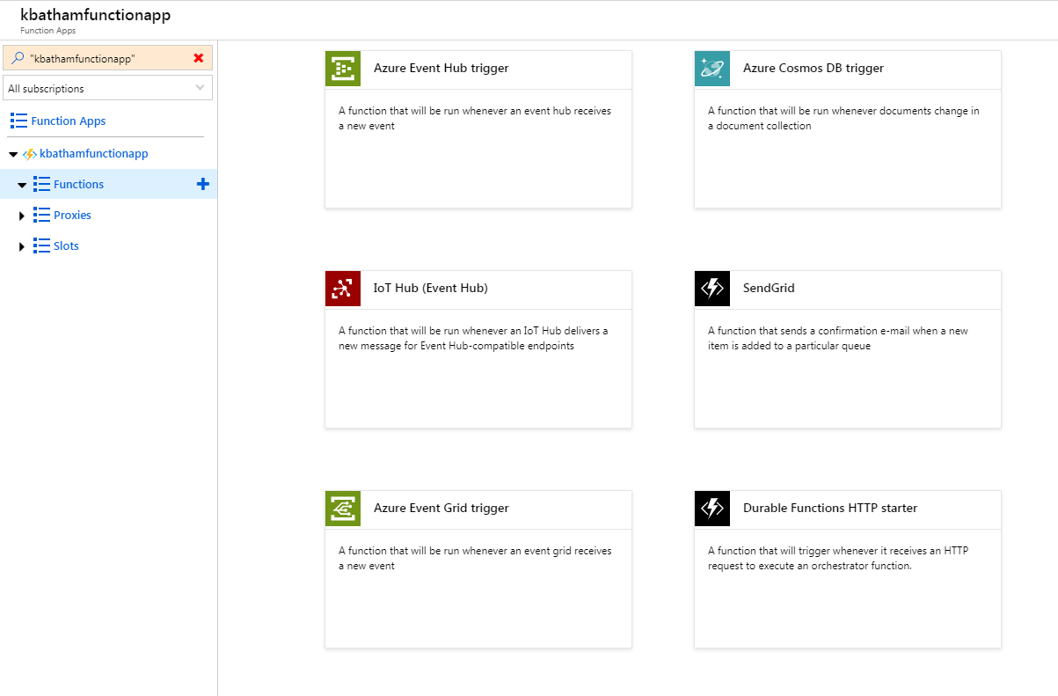

Let’s Select the Timer Trigger & create

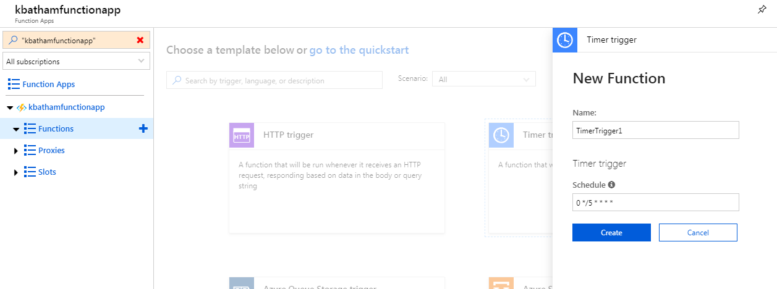

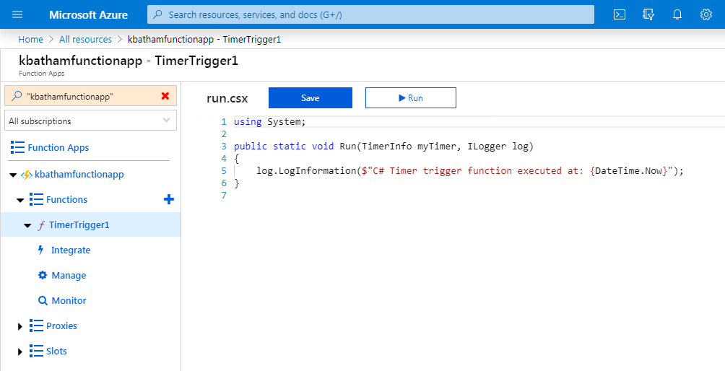

Now we can go here and start to write .Net code, you can integrate the trigger using Input and Output features.

Select Integrate 🡪

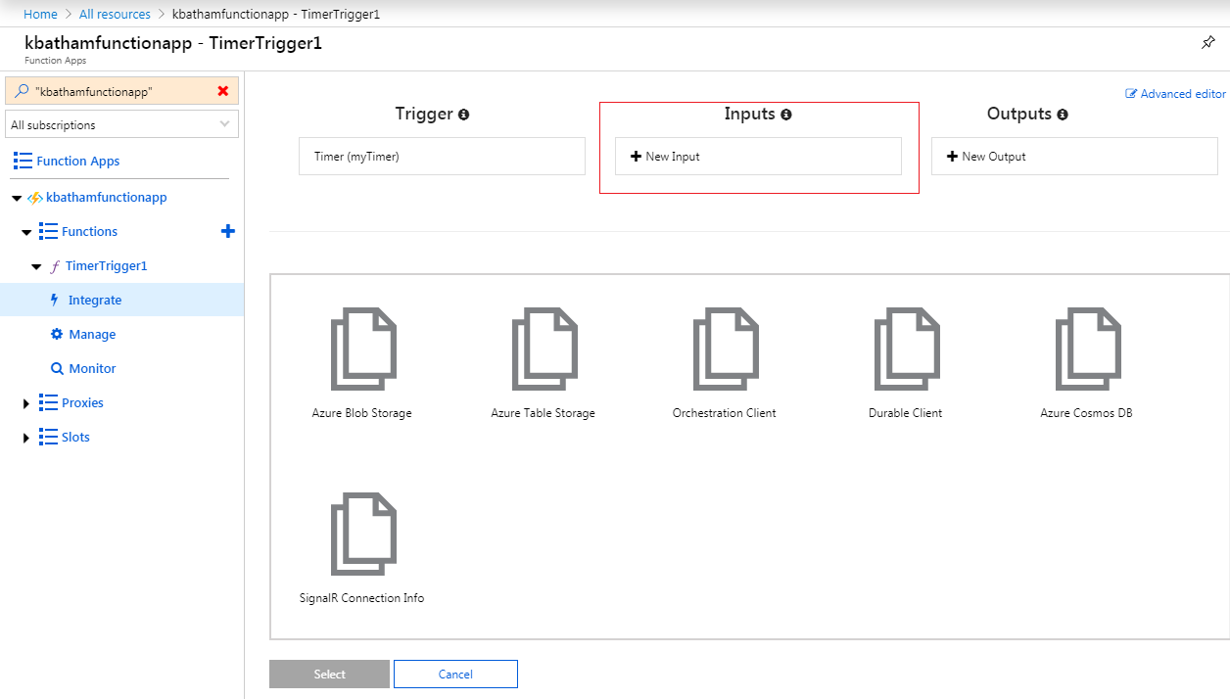

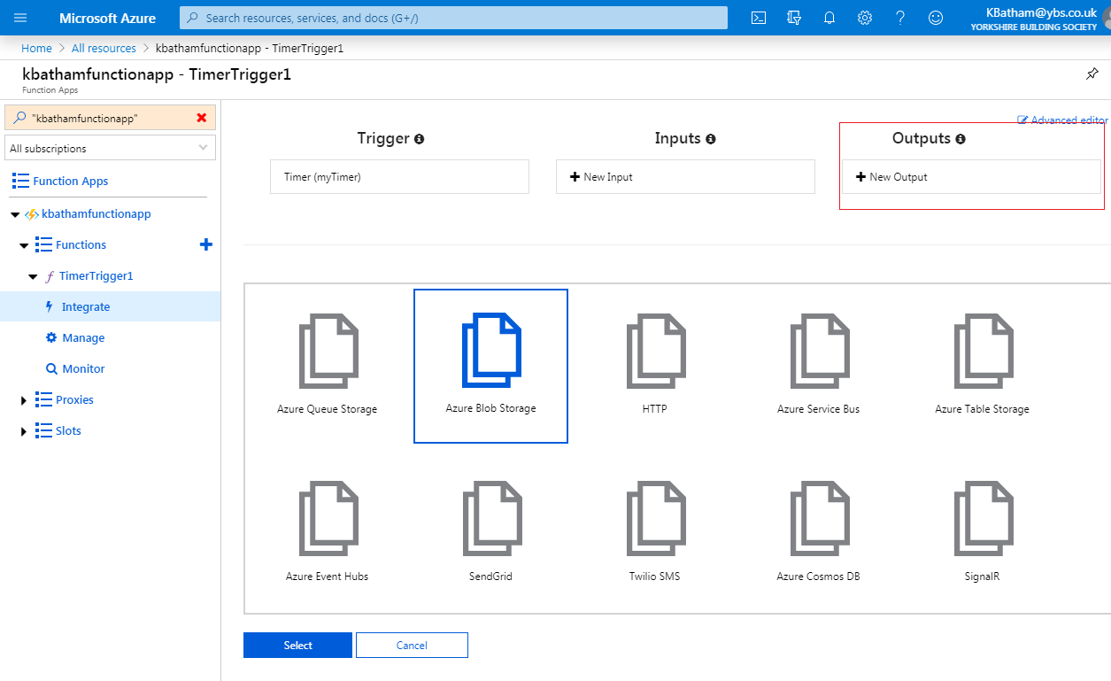

Create output string here 🡪 pass the output string value into function as below

Save the change and run

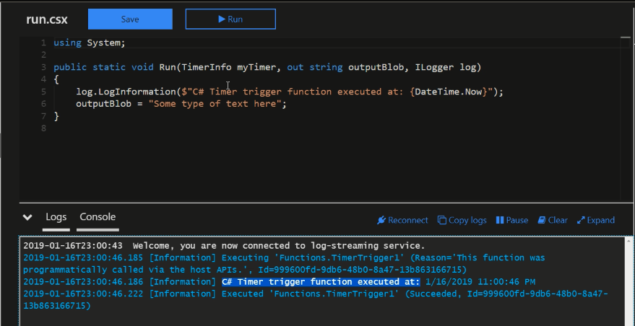

Go to Storage Account 🡪 Blob 🡪 Outcontainer 🡪 You can see the logs

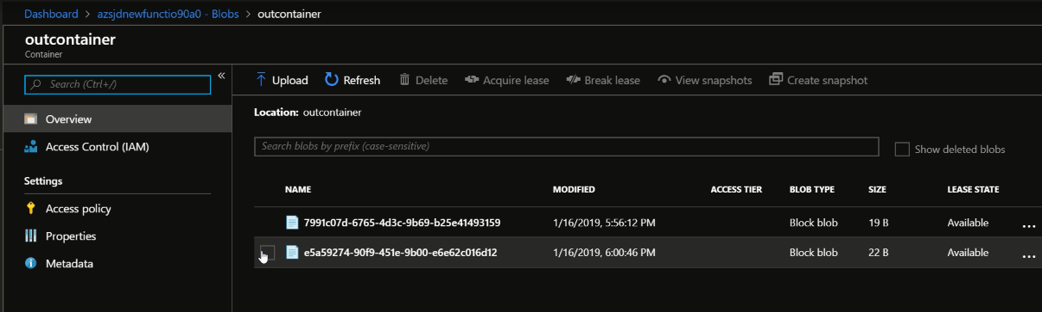

* 1. **Durable Function:**

In case of you need to meet more complex function, how can you design your function in Azure?

Go to Function 🡪 Click Add 🡪 More template 🡪 you can see the list of Durable function

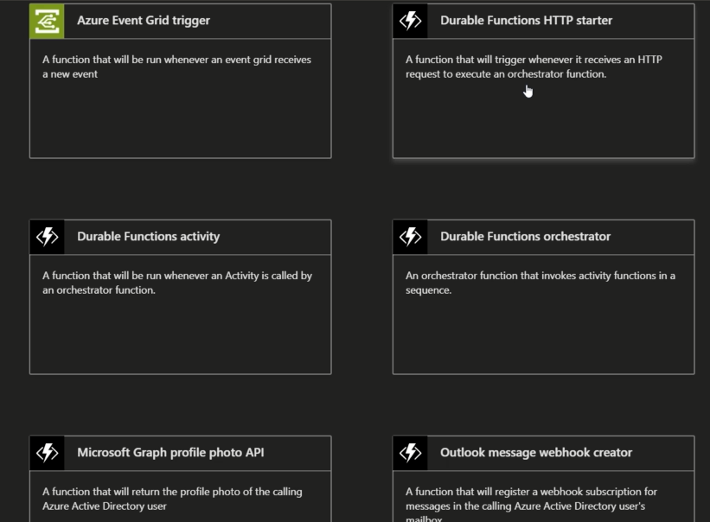

* 1. **Visual Studio and Function:**

Go to Visual Studio 🡪 Cloud 🡪 Azure Function is option

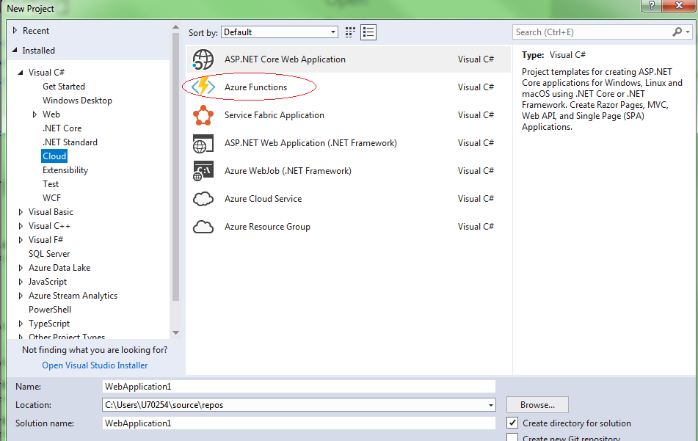

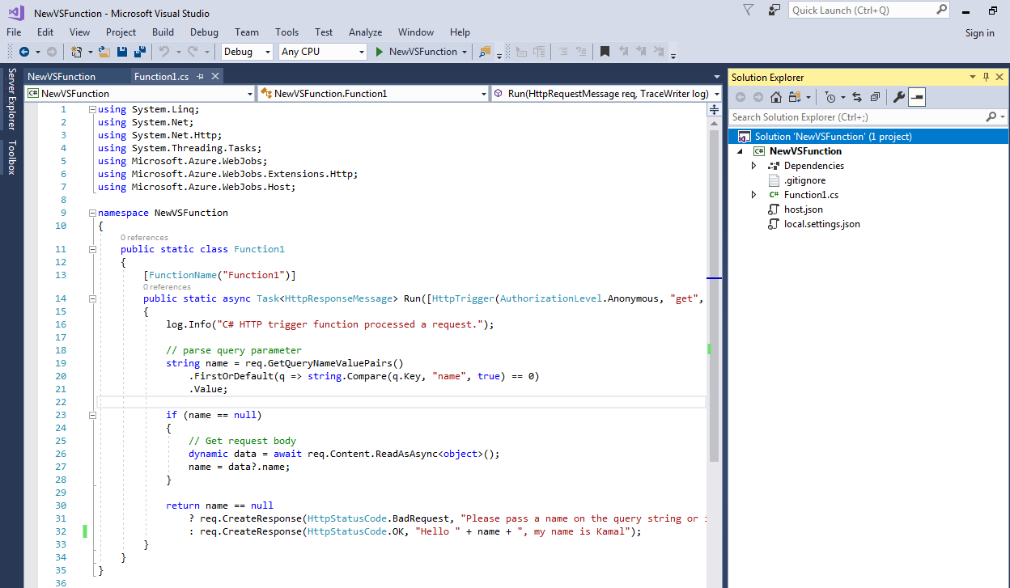

Build project and publish

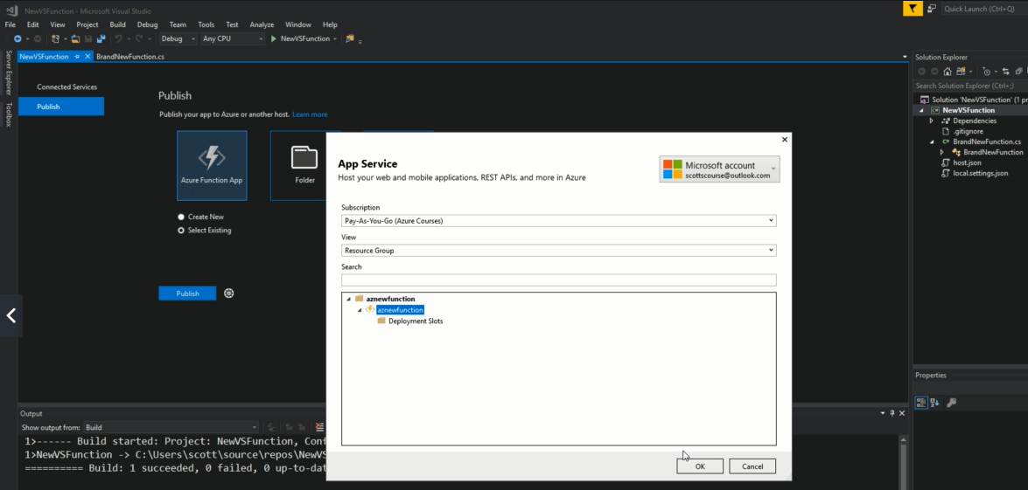

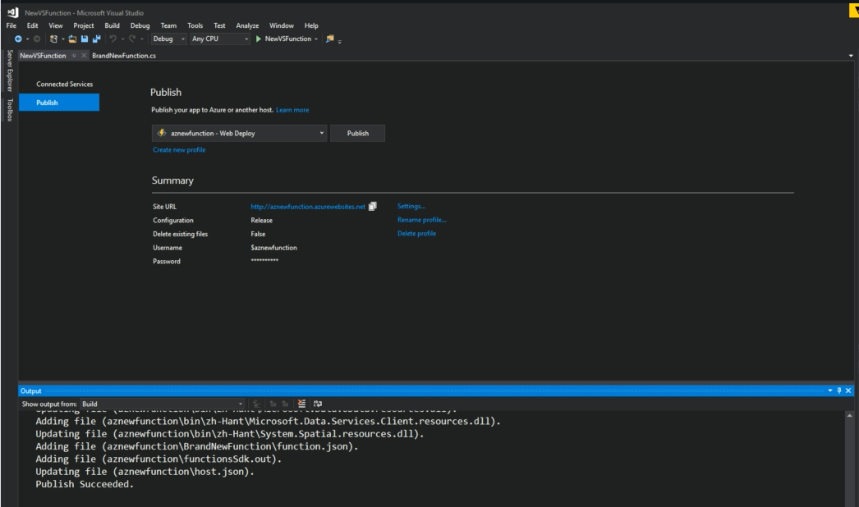

Go to your Function

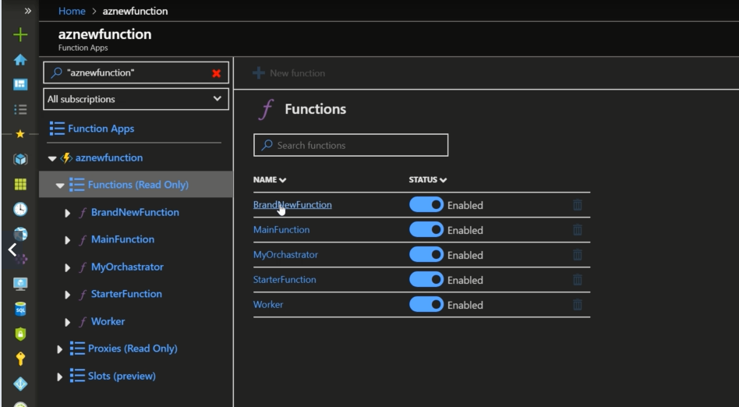

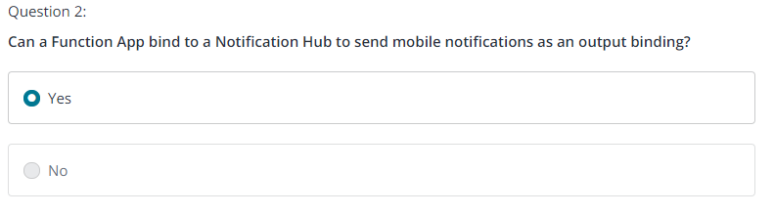

* 1. **Code Sample: Durable Functions**

Since the AZ-203 exam will want you to develop Durable Functions, here is a relevant Getting Started Github project:

<https://github.com/Azure-Samples/durablefunctions-apiscraping-dotnet>

* 1. **Hands-On-LABS: Create a Durable Function**

Follow the instructions in the attached PDF to create your own durable Functions. I encourage you to try this yourself.



1. **New AZ-203 Azure Storage Account**
   1. **Overview of Azure Storage Options**

To store data and file into Microsoft Azure, you can store tables, queues, blobs. So when you create a VM, you need to create a storage account to store files in hard disk.

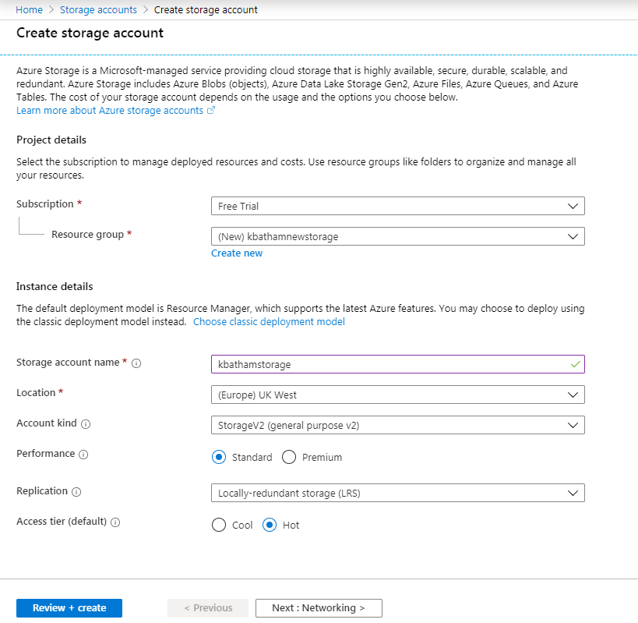

We have three different account types as shown below

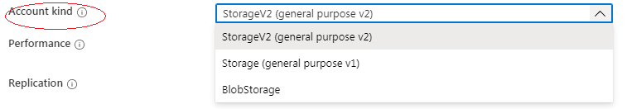

Microsoft recommend StorageV2, StorageV1 is oldest model, V1 is economical if you do lot of transaction as compare to V2

Blobstorage 🡪 If you need anonymous access of your storage account for images than you may prefer

**Three different type of Replication:**

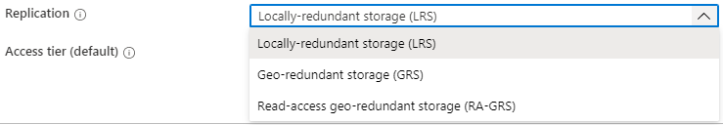

LRS 🡪 When you have data kept in three total locations, Microsoft automatically going to store two addition copy of file, so in case of backup required

GRS 🡪 Microsoft keep six copies of your data, also take data outside of the region to maximise the availability.

RA-GRS 🡪 Not only store the data in regions but you also have access in read-only fashion.

Azure storage offers different access tiers, which allow you to store blob object data in the most cost-effective manner. The available access tiers include:

* Hot - Optimized for storing data that is accessed frequently.
* Cool - Optimized for storing data that is infrequently accessed and stored for at least 30 days.

**Set the networking 🡪**

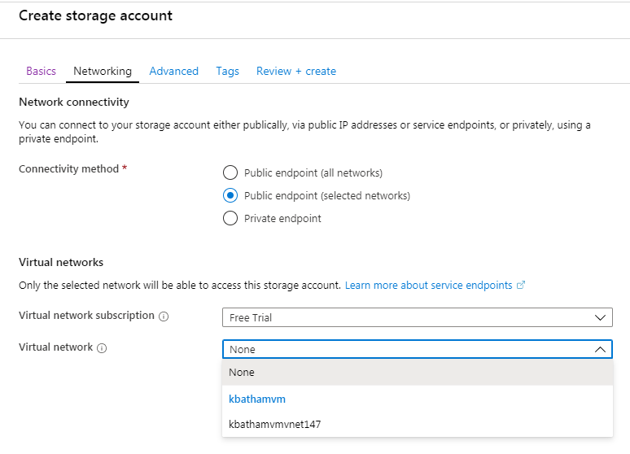

Further you can set the secure transfer require (Open transfer HTTP, or want to user secure HTTP for data transfer)

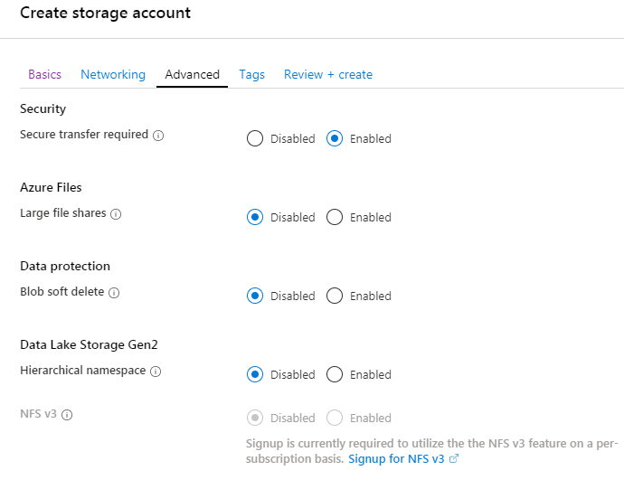

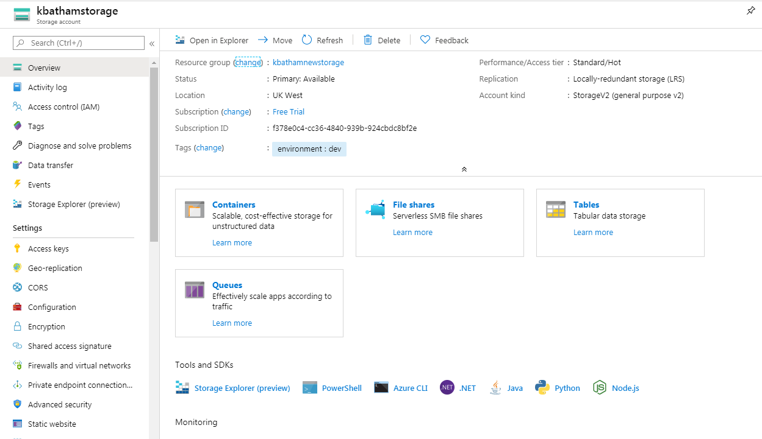

Storage account provides 4 different services as below

Each of these services have their own unique URL

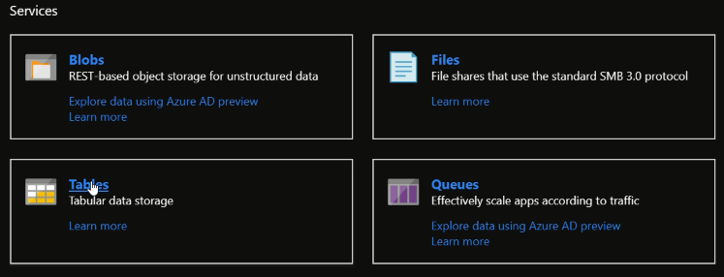

* 1. **Azure Table Storage**

Remember that Storage account is public by default, so all the services created can be accessed publicly.

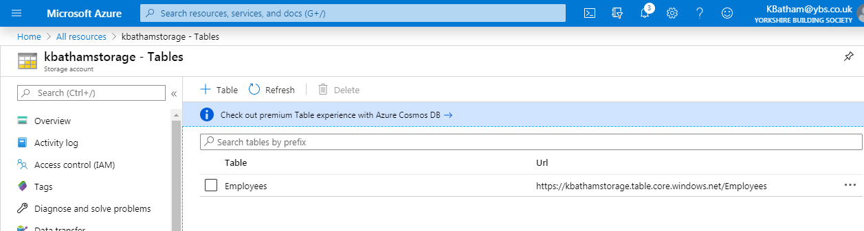

So from code either in .Net you can connect with this table using URL (<https://kbathamstorage.table.core.windows.net/Employees>)

* 1. **So how to use this table in our program**

Create a console application 🡪

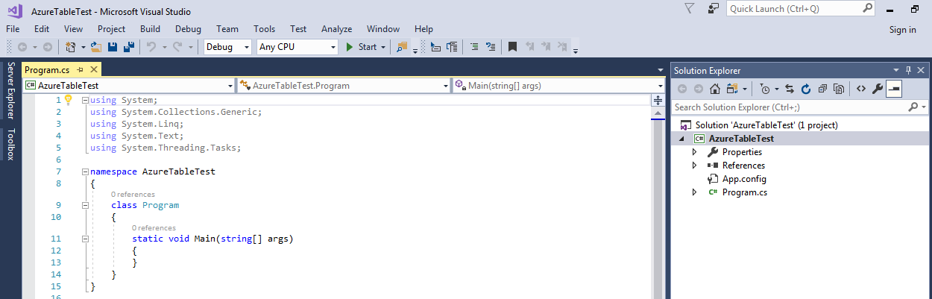

Go to nugget package manager 🡪 browse 🡪 Azure Storage 🡪 Select WindowsAzure.Storage, Install it

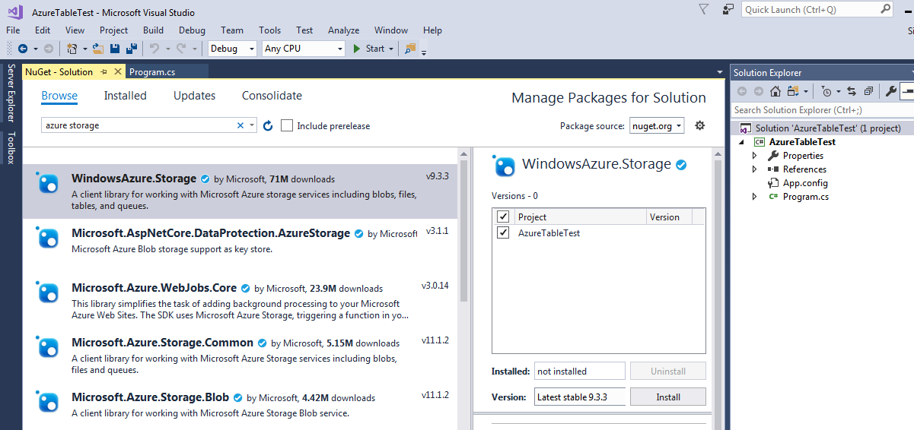

Now go to program.cs and add the below reference to use & access the Azure storage.

using Microsoft.WindowsAzure.Storage;

using Microsoft.WindowsAzure.Storage.Table;

Now you need to create a client to connect with your Azure storage 🡪 You need connection for this 🡪 go to your storage account 🡪 Get the connection string

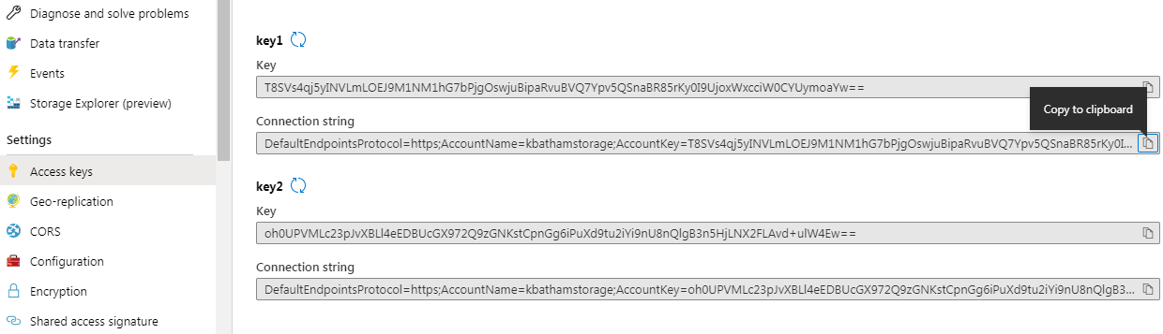

Note: It’s not recommended to use Access Keys, better to create Shared Access Signature

You can see the multiple Table operation as shown below that you can perform.

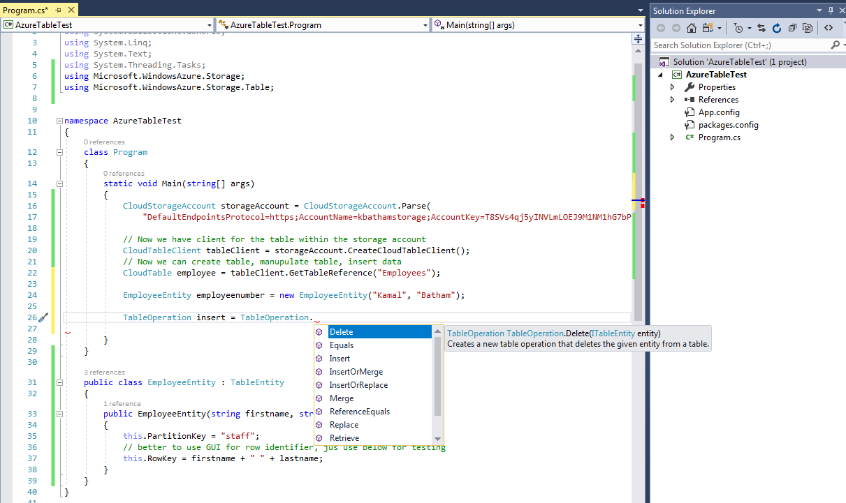

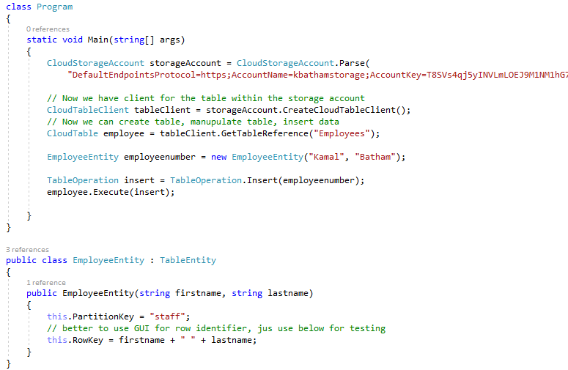

* 1. **Query From the Table**

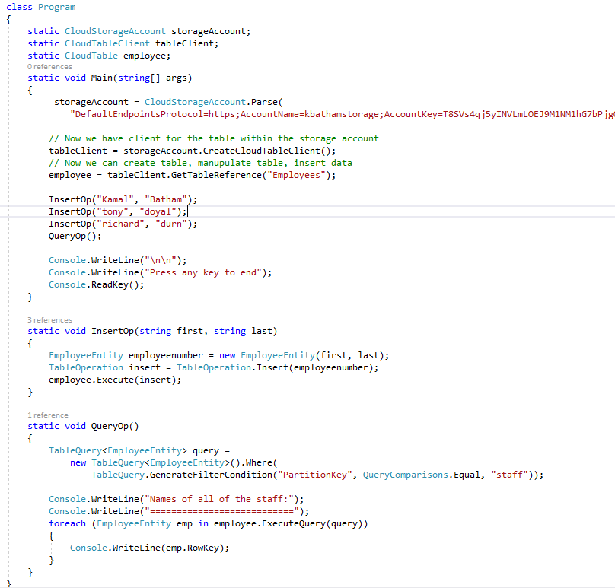

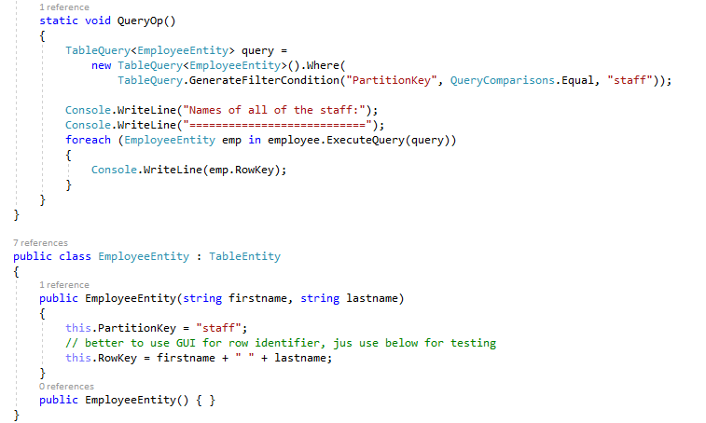

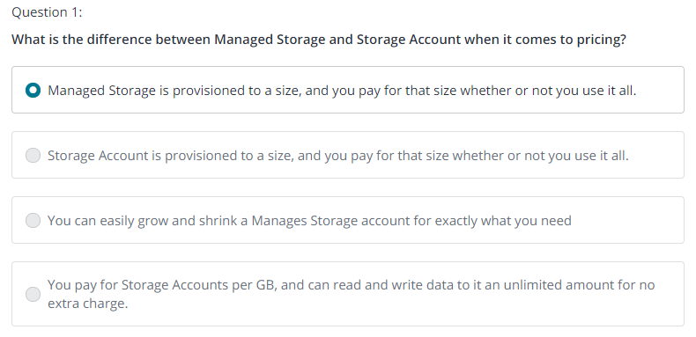

* 1. **Code Sample: table Storage**

Since the AZ-203 exam will want you to develop against Table Storage, here is a relevant Getting Started Github project:

<https://github.com/Azure-Samples/storage-table-dotnet-getting-started>

1. **New AZ-203 CosmosDB**

In previous discussion, we have looked into Table, however Microsoft recommend using premium Table experience with Azure Cosmos DB

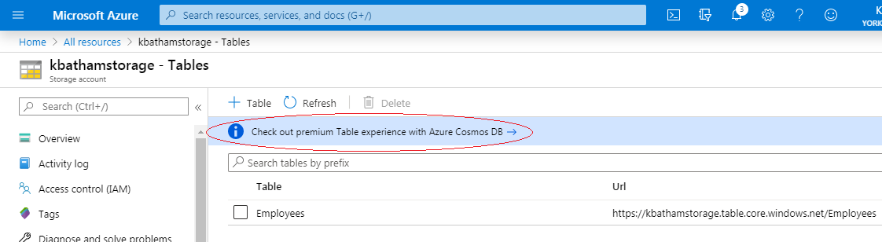

CosmosDB has the ability to dealing with large scale of transaction. For example, you build a mobile app, and want to have millions of store in Azure storage account 🡪 In that case better to go for CosMosDB 🡪 It doesn’t offer any relationship between tables 🡪 so it is kind of un-relational database

Create CosmosDB

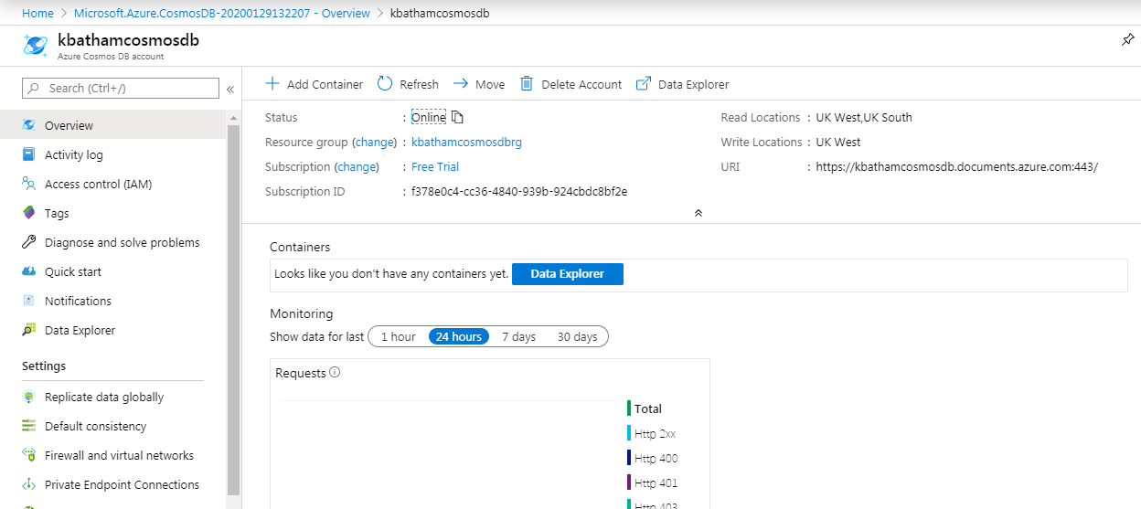

Add new Container 🡪

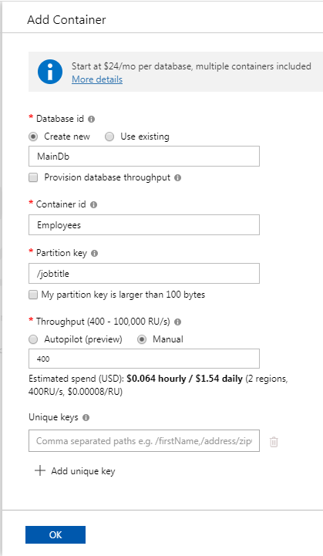 🡪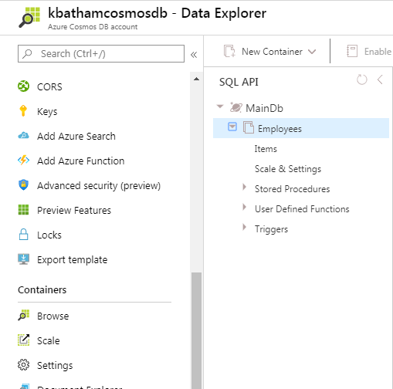

* 1. **So how to use this table in our program**

First add reference of Microsoft.Azure.DocumentDB

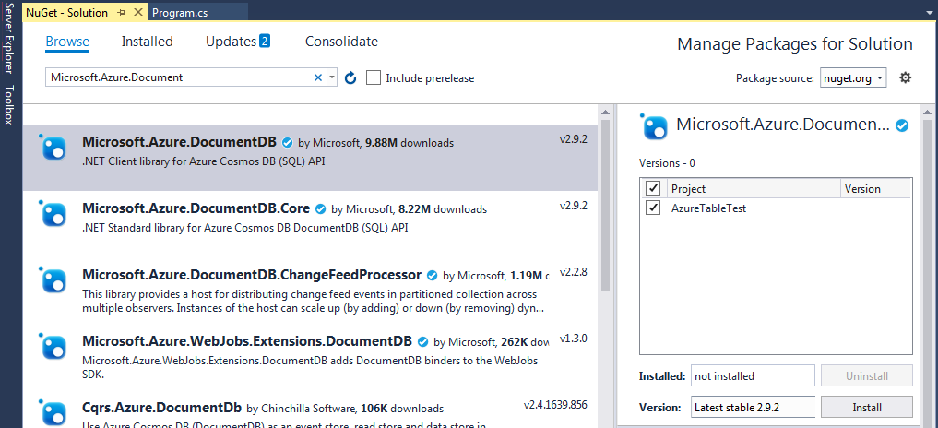

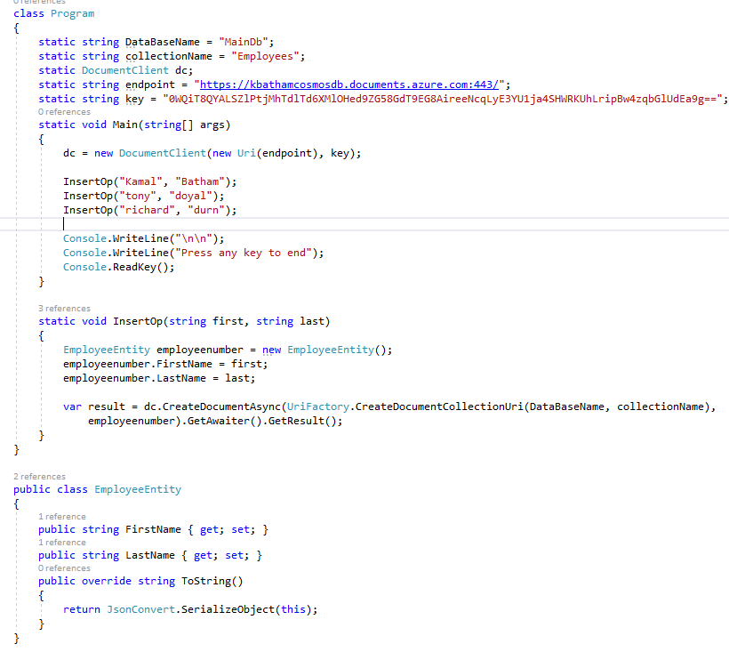

Fetch the record from Cosmosdb

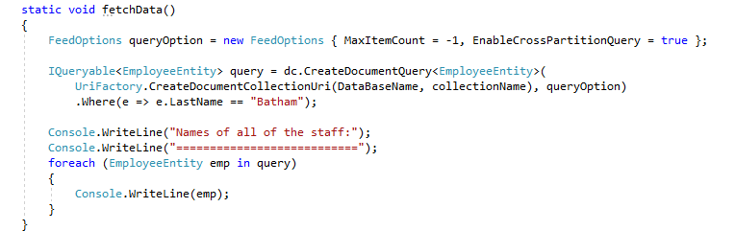

* 1. **Setting Data Consistency Options**

CosmosDb provides five different type of consistency, Session consistency is default.

* Strong
* Bounded staleness
* Session
* Consistent prefix
* Eventual

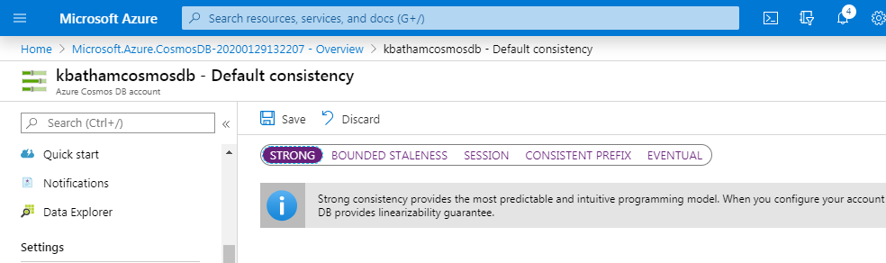

**Strong**: Strong consistency offers a linearizability guarantee. Linearizability refers to serving requests concurrently. A client never sees an uncommitted or partial write. (When a region writes the data 🡪 all other regions data replicated and can read the data exact same moment)

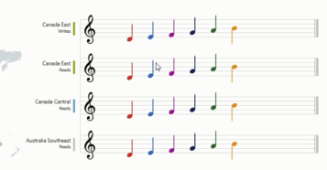

**Bounded staleness:**

Data is consistence with same order but you can define the maximum leg time, by default its 5 second for single region

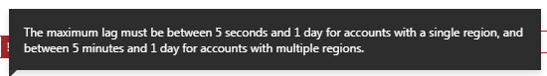

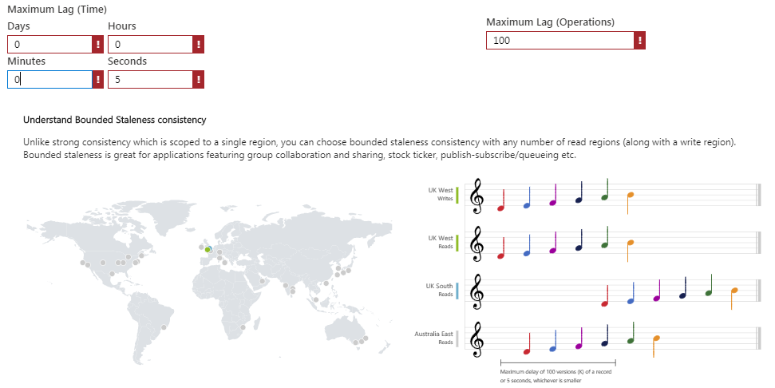

**Session:** It’s similar to strong, but applicable for same region as shown below.It can have unprecedented delay for different region.

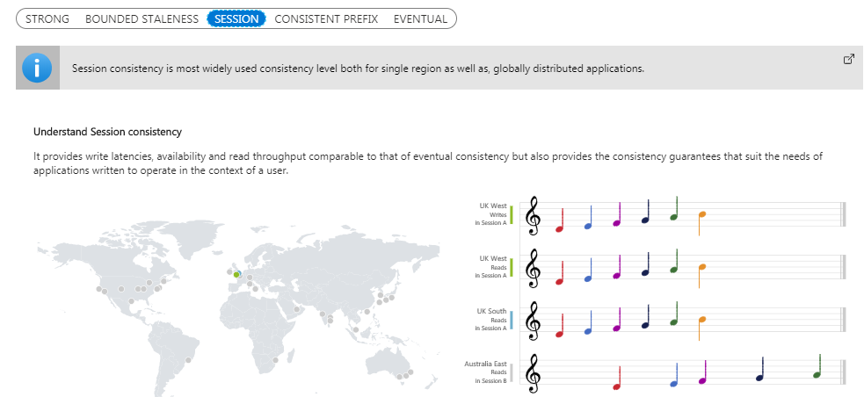

**Consistent Prefix:** it guaranteed that data always come in right order but can have delay

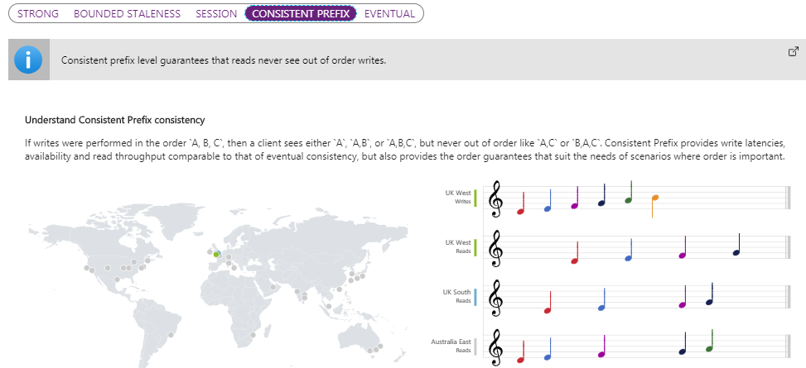

**Eventual**: There's no ordering guarantee for reads. In the absence of any further writes, the replicas eventually converge.

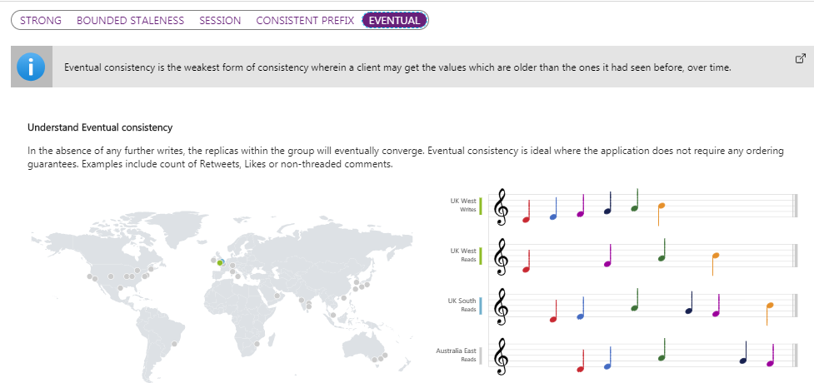

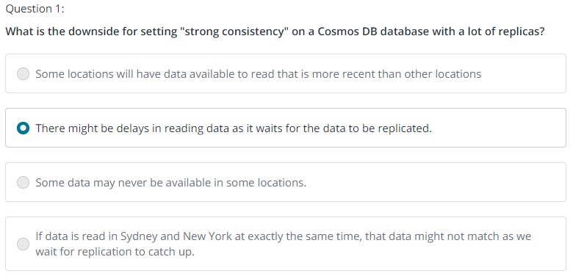

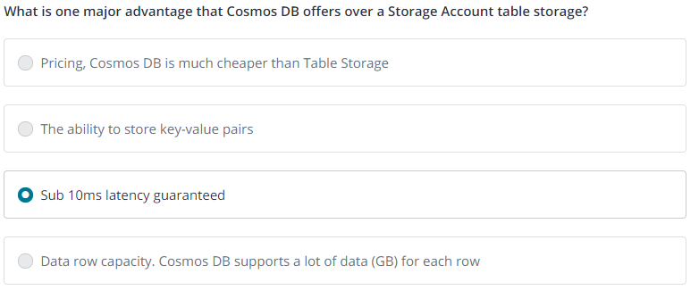

* 1. **Code Samples: Cosmos DB QuickStart**

Since the AZ-203 exam will want you to develop against Cosmos DB, here is a relevant Getting Started Github project:

<https://github.com/Azure-Samples/dotnet-cosmosdb-quickstart>

This code is .NET Core. Other languages and samples are available in that repository.

1. **New AZ-203 SQL Database**

Azure SQL Database is as a database as a service solution, it looks very much like SQL server.

Some advance feature like coalition, full text indexing not supported, for this you need to go for

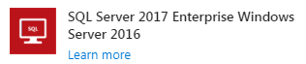

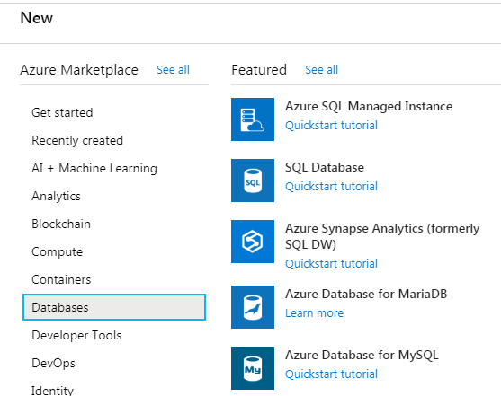

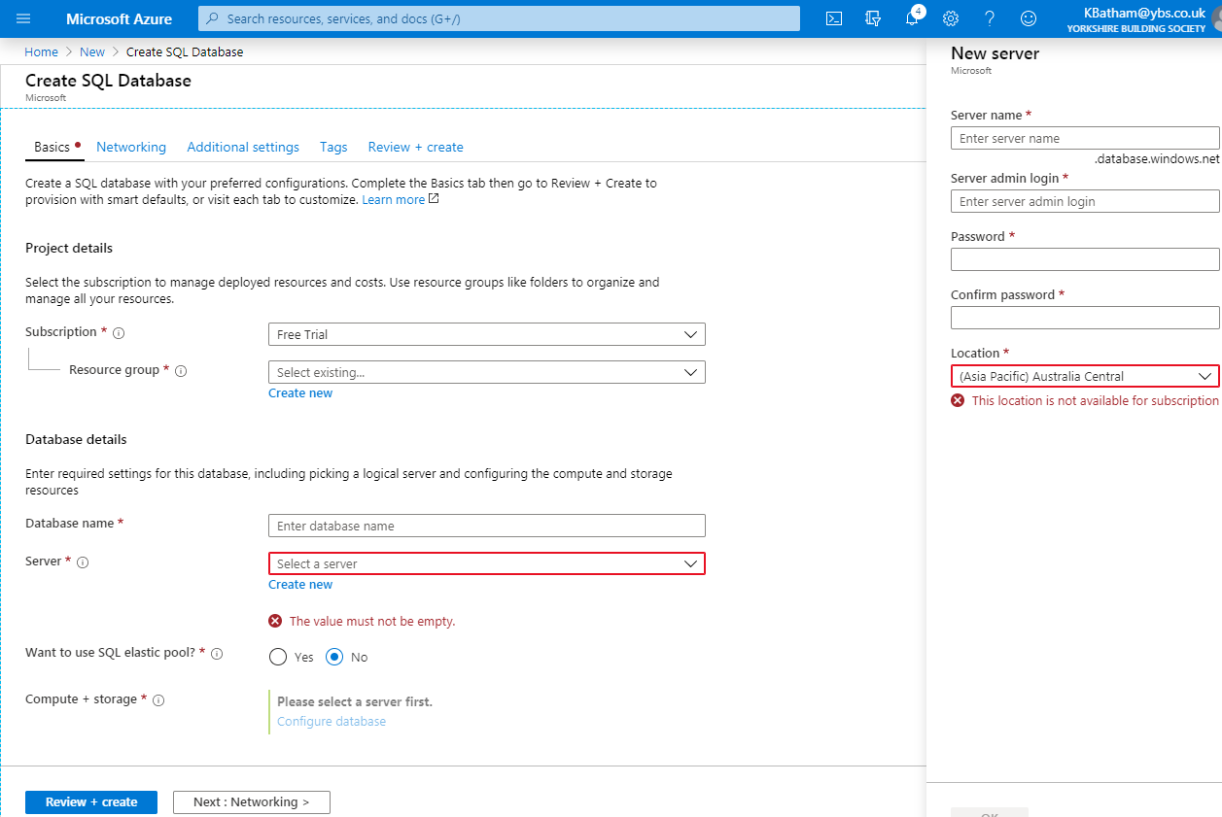

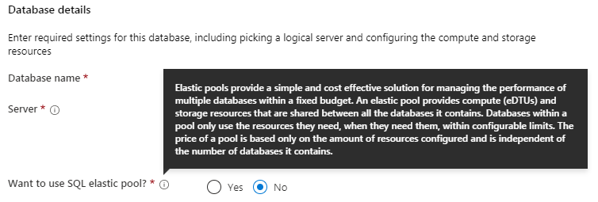

You can create the backup of your database 🡪 Go to Geo-Replication 🡪 choose the region 🡪 and create backup database.

* 1. **Updating SQL Database Firewall**

Click on Database server 🡪 you will see the firewall link, where you can set the configuration of firewall.

* 1. **SQL Server Management Studio**

In order to access the database created 🡪 you can use your local SQL server management studio

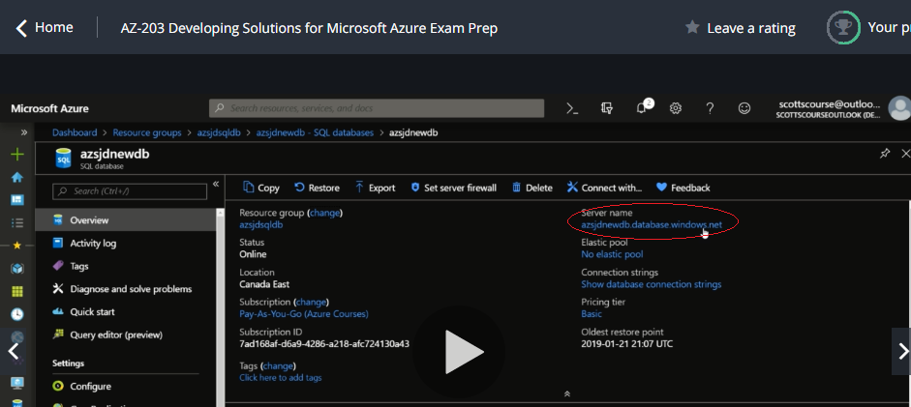

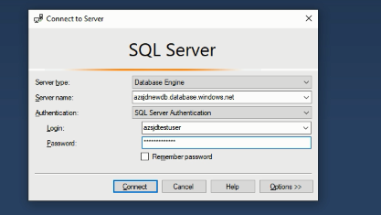

* 1. **Code Sample: SQL DB**

Since the AZ-203 exam will want you to develop against SQL Database, here is a relevant Getting Started Github project:

<https://github.com/Azure-Samples/dotnet-sqldb-tutorial>

This code is .NET Framework. Other languages and samples are available in that repository.

1. **New AZ-203 Blob Container**

Blob is just a container, where you can throw files.

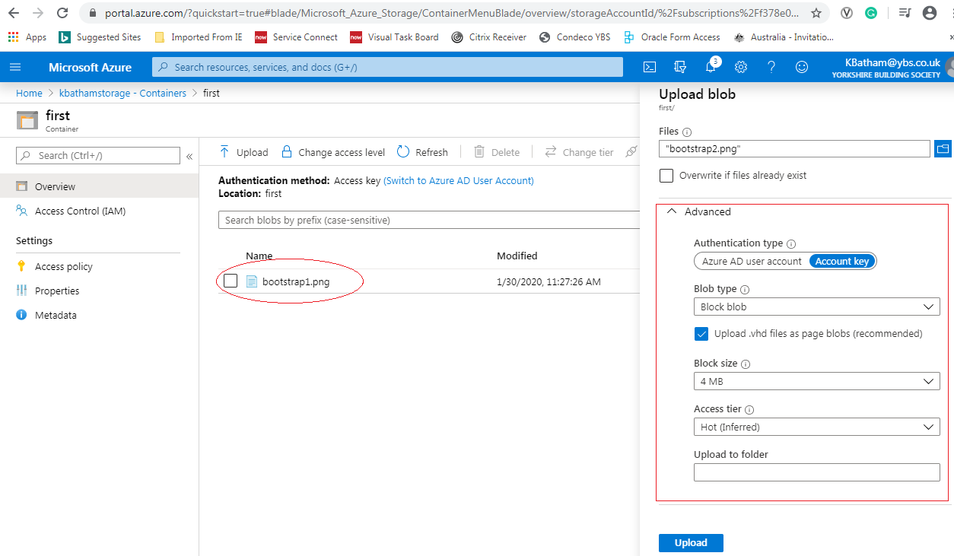

To Access the image and move it to another folder 🡪 you can download the AzCopy from below link and install it. And configure the path into environment variable.

<https://docs.microsoft.com/en-us/azure/storage/common/storage-use-azcopy-v10>

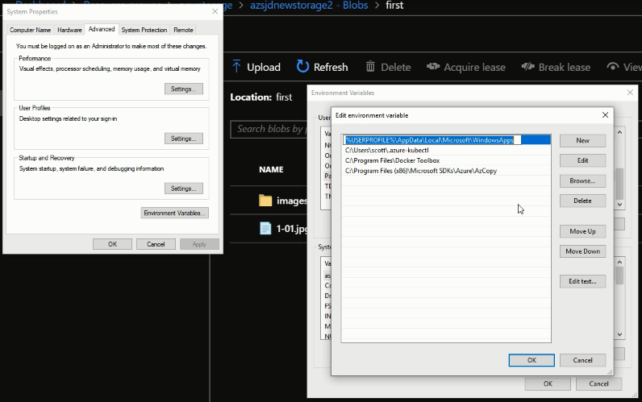

Use Powershell 🡪

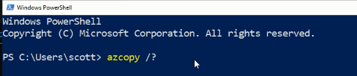

It will show some example to copy the image into blob

First Login into Azure Account by powershell

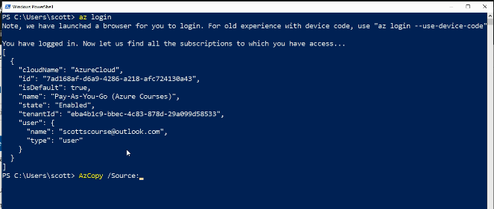

Source will be the container 🡪 Go and click on container properties 🡪Copy the URL

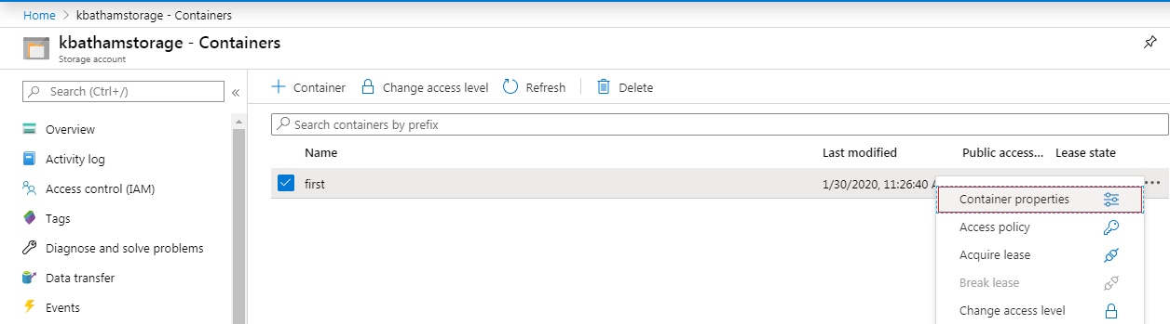

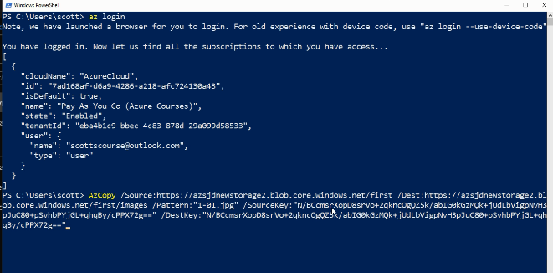

Acquire lease 🡪 actually acquire the lock in the file, so it can’t be modified or delete

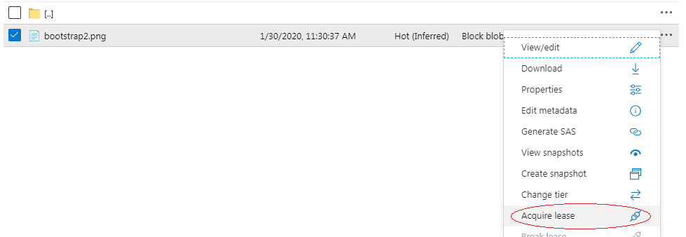

* 1. **Code Sample: Azure Blob**

Since the AZ-203 exam will want you to develop against Azure Blobs, here is a relevant Getting Started Github project:

<https://github.com/Azure-Samples/storage-blob-dotnet-getting-started>

1. **Az-203 Azure Authentication**
   1. **Introduction to Azure Active Directory**

Azure Active Directory is an Identity and Access Management as a service (IDaaS) solution that extends your on-premises directories into the cloud and provides single sign-on to Azure, Office 365 and thousands of cloud (SaaS) apps and access to web apps you run on-premises.

Azure active directory is not same as corporate active directory which manage account, user group and their authentication.

**Azure AD Connect –** We user it to synchronize on-premises active directory to Azure active directory.

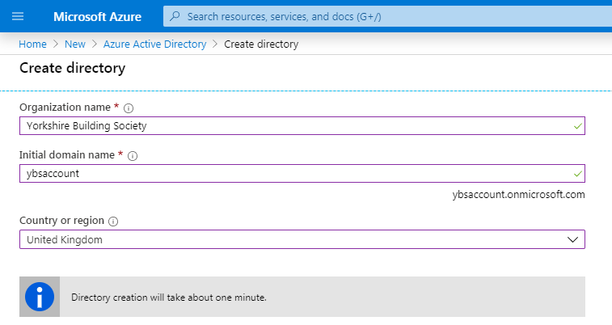

Create Active Directory 🡪 in order to switch to another active directory 🡪 click on Switch Directory

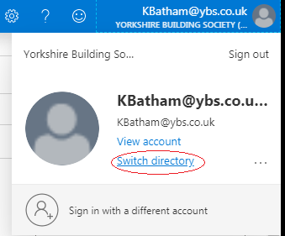

Select the directory which you want to choose 🡪 It will give you another fresh space with no resource added 🡪 it just like you newly go to your azure account

* 1. **Access Azure AD using Code**

Go to 🡪 <https://github.com/AzureADQuickStarts/AppModelv2-WebApp-OpenIDConnect-DotNet>

Download the code – Build it

You can get more detail how it works🡪 <https://docs.microsoft.com/en-us/azure/active-directory/develop/tutorial-v2-asp-webapp>

Open web.config file 🡪 you will see that it asking for client ID

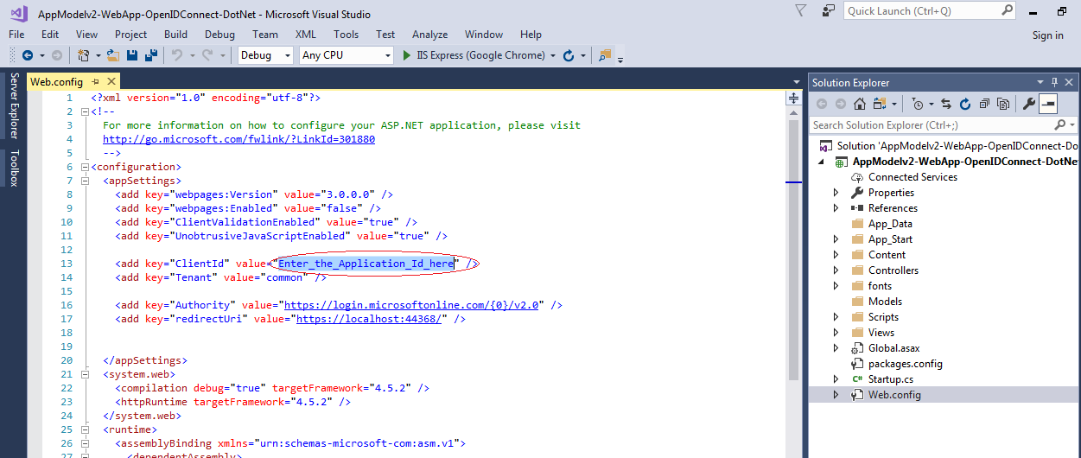

Go to your new directory 🡪 user App Registration 🡪 Register it as a new application

When you register, it will ask you redirect URL 🡪

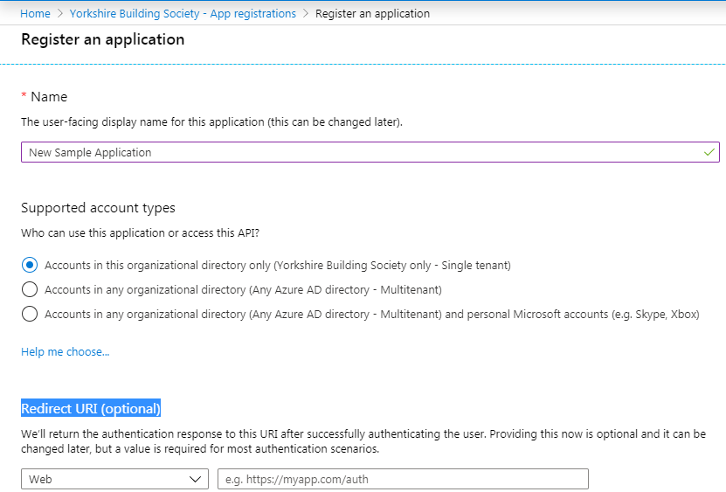

So for that Deploy this solution, either into Azure Web App, or in IIS 🡪 give the path of that URL

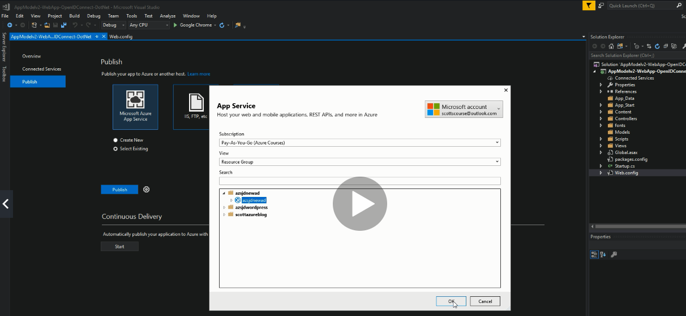

Deploy it 🡪 Get the URL 🡪 update it into redirect URL above. 🡪 Note URL should be HTTPS

Now get the Application ID and update into web.config file as ClientId and RedirectUL as Publish URL

Now publish the code again.

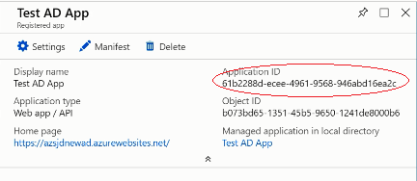

* 1. **Multi Factor Authentication**

Azure active directory has built-in feature of multifactor authentication

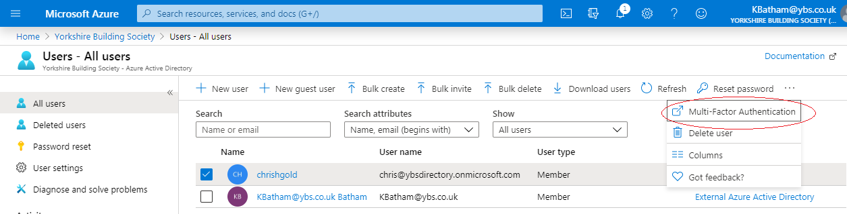

Click on multifactor Authentication 🡪 It will redirect you below page

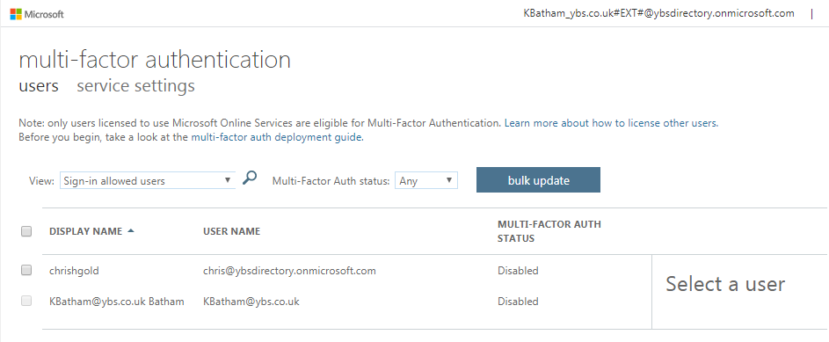

Select the user and Enable the Multifactor Authentication

* 1. **Code Samples: Azure Active Directory**

Since the AZ-203 exam will want you to develop against Azure AD, here is a relevant Getting Started Github project:

<https://github.com/Azure-Samples/active-directory-dotnet-native-desktop>

This code is .NET Framework. Other languages and samples are available in that repository.

1. **Az-203 Azure Access Control**
   1. **Role Based Access Control (RBAC)**

You want to grand access to user a least amount of permission that they need to work done

Granting access to people within your organisation into your azure resources 🡪 you want to give them minimum privileges

Go to All Services 🡪 Subscription

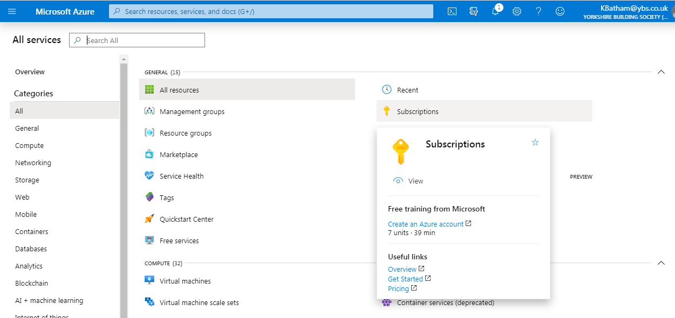

Go to your subscription 🡪 click

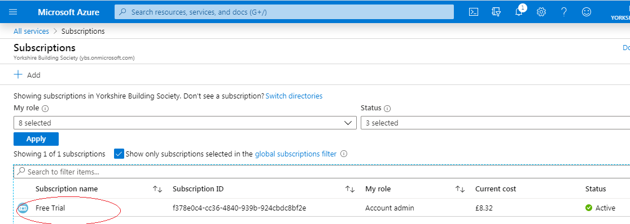

Go to Access Control

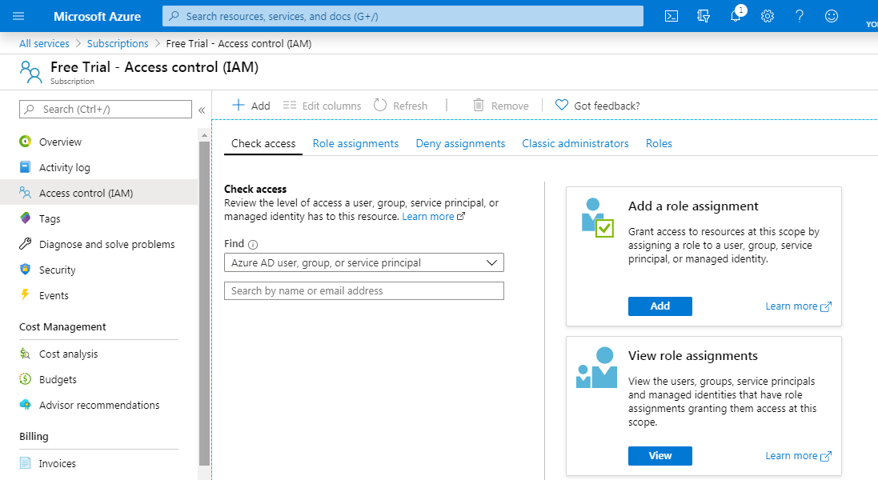

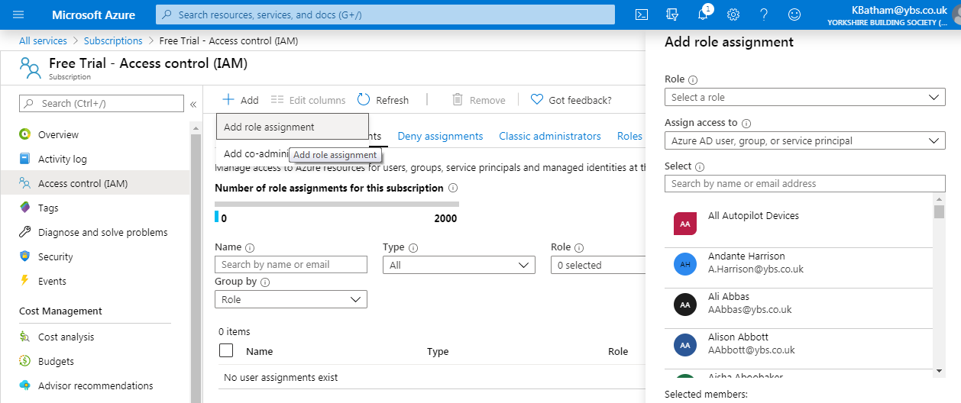

1. **Az-203 Secure Data**

In this section we will talk about the data security and encryption

* 1. **Data Encryption and Storage Accounts**

Go to your storage account 🡪 Click on encryption 🡪 you will see that storage account is encrypted by default.

Moreover you cannot turn off it.

You can use your own key as well

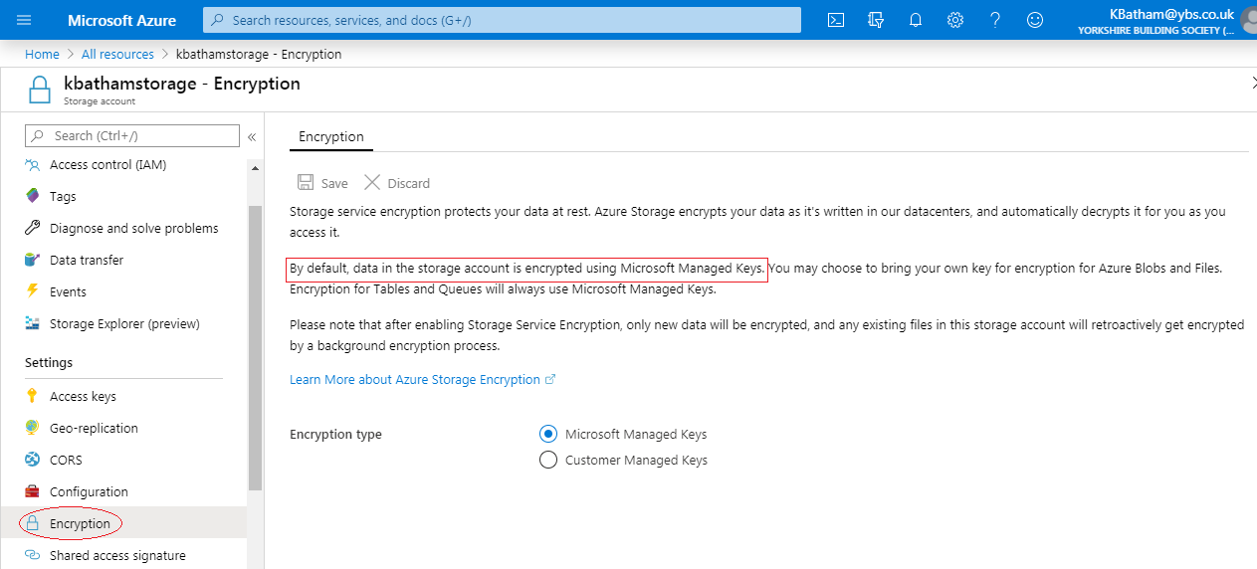

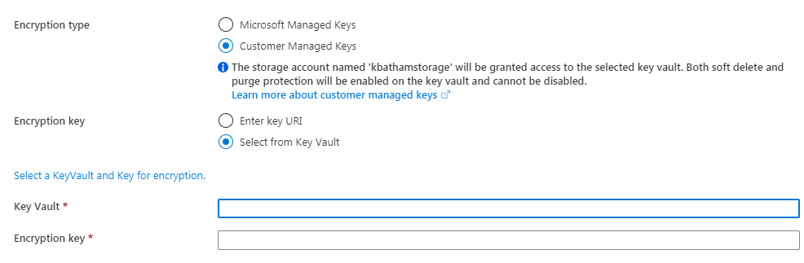

Other aspect of encryption in storage account 🡪 Called encryption in transit 🡪 Once Microsoft store your file, it encrypted into hard disk, then somebody need to read the file 🡪 the file got un-encrypted

If that file need to transfer from storage account 🡪 to your application to a VM or outside of Azure 🡪 than how you can protect that 🡪

For that go to configuration 🡪 enable secure transfer over HTTPS

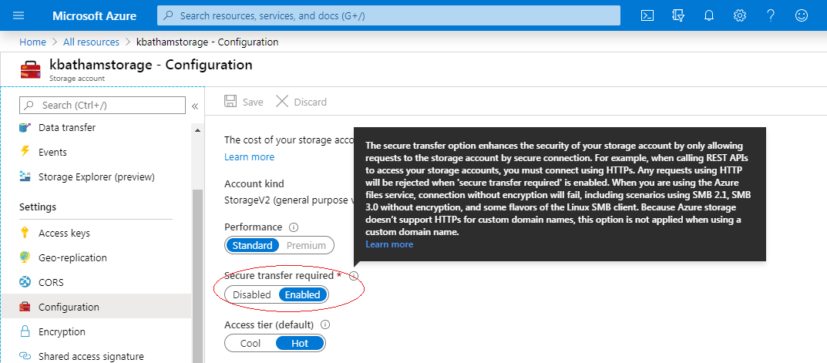

* 1. **Data Encryption and SQL Database**

Now other type of data storage in Azure is Database 🡪 Go into your Azure Database 🡪 Go up to server level 🡪 go to security

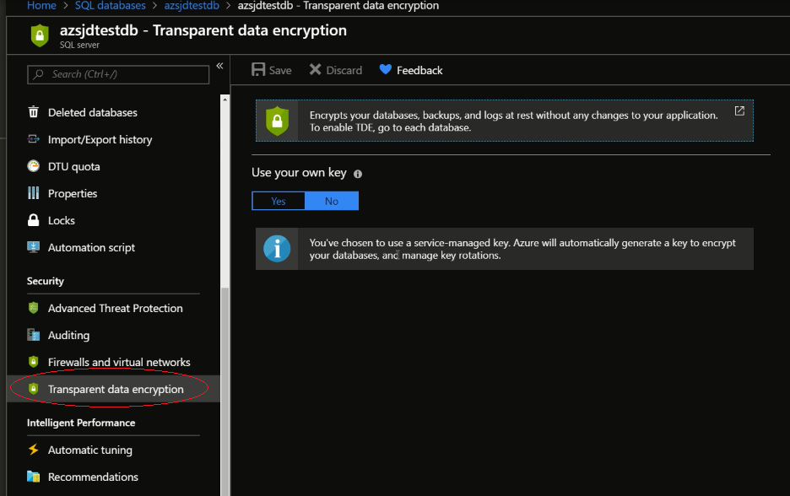

Microsoft has created their own key to encrypt database 🡪 so our data is stored in encrypted manner but it is transparent to us.

When you do select statement 🡪 it retrieves the data and unencrypts it

Just like Storage (Above) 🡪 You have option to secure your data by Key Vault or entre key identifier

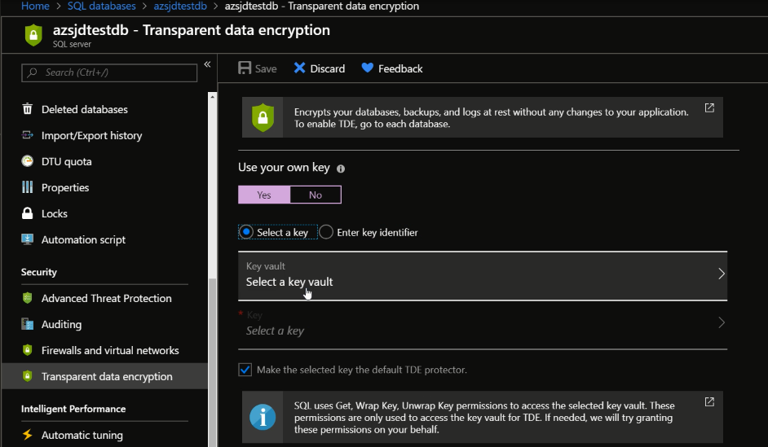

Now this is at the server level 🡪 If we have to do database level than 🡪 Go to SQL database 🡪 Choose the database 🡪 You have same Transparent data encryption

Where you can decide whether you need data to be encrypted or not

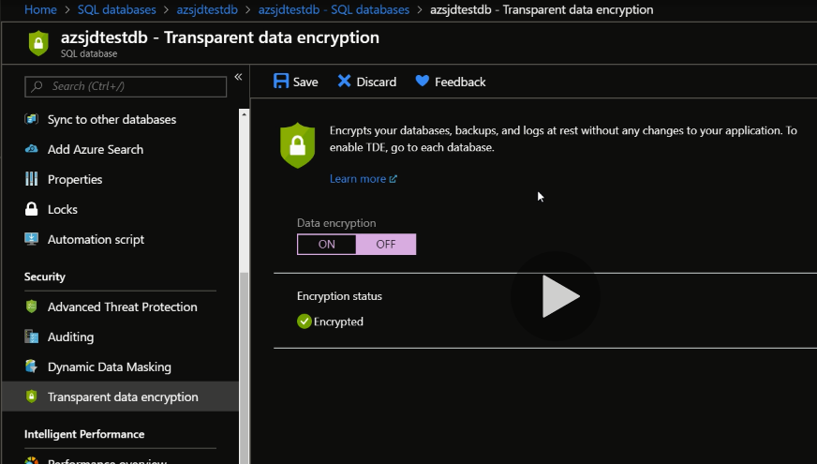

You can set it off in the case when your data encrypted at application level, so in this situation, double encryption would be waste

Master database cannot be encrypted

* 1. **Azure key Vault**

Use Azure Key vault for encryption 🡪 Create your key vault 🡪 set up Keys, secrets, certificates

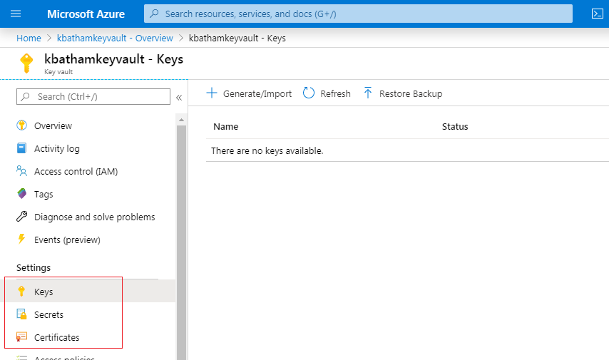

Keys 🡪 Generate or import security key, put that into your key vault and use it for your disk encryption.

Secrets 🡪 let’s say you have API (weather service), in order to call it you need to use it security key as part of API call

Traditionally you put the security code into Web.config file in the code, and application just call the configuration method and get the key from config file.

Other ways – you can store key into key vault

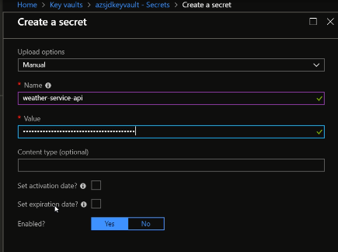

Now when you create secret 🡪 Click on secret created 🡪 you will get the url, which you can use to access the API

By below method you can access the secret in the code.

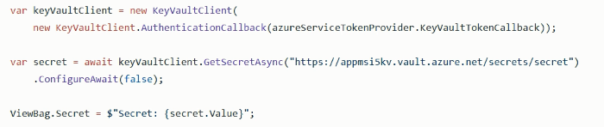

Certificate 🡪 certificates are uses for signing things, like SSL, HTTPS 🡪 you need to generate certificate

You can use the code to access the secrets and certificate, and also used in Arm-templates

* 1. **Code Sample : Azure Key Vault**

Since the AZ-203 exam will want you to develop against Azure Key Vault, here is a relevant Getting Started Github project:

<https://github.com/Azure-Samples/key-vault-dotnet-manage-key-vaults>

This code is .NET Framework. Other languages and samples are available in that repository.

1. **Az-203 Scaling Apps and Services**

Scaling means dynamically grow when demands for your application goes up, and shrink down when demands goes down. Azure provide help you to manage it programmatically to manage more traffic and shrink down when traffic low.

* 1. **Manual Scaling of Azure App Service**

Scaling not offered in free plan, so you can use scale up and scale down feature

Go to your App service 🡪 Define Scale Up and Scale down

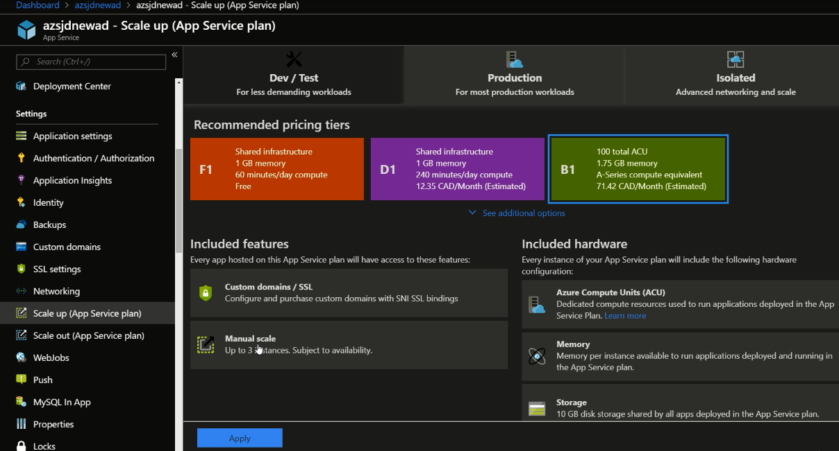

Benefit of B1 scaling is Manual scale, which can offer up to 3 instance of your app running

In Scale Out 🡪 you can manually set up to 3 instances to run, and when demand is low you can set it to one.

**Note:** Autoscale is not supported in this tier, It can found in Production Tab

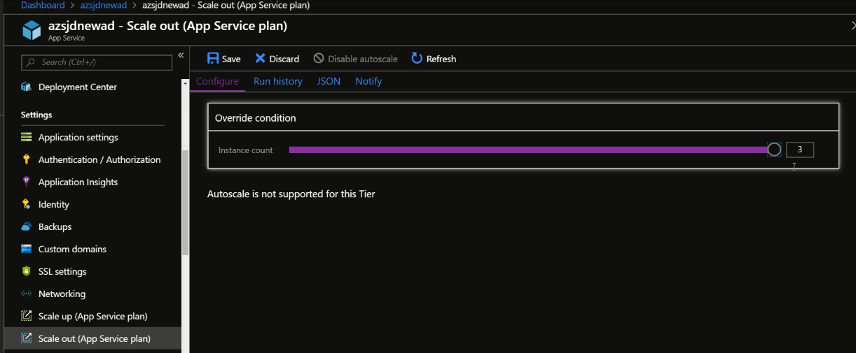

* 1. **Automatic Scaling of Azure App Service**

Stander plan provide feature of auto scaling 🡪 Click on Scale out 🡪 You will see the button of auto scalling

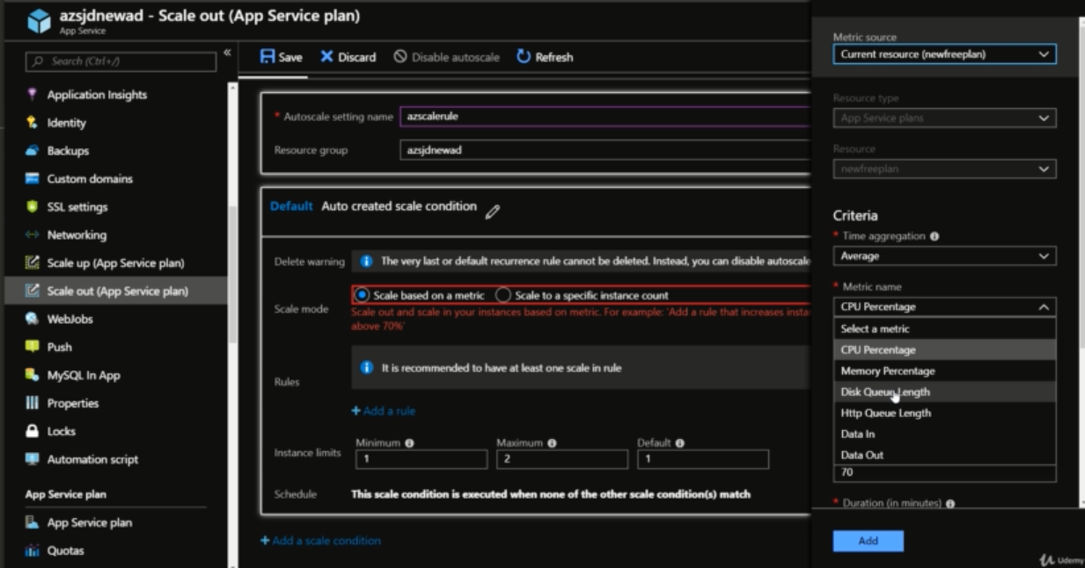

Matrix defined below 🡪If utilization of CPU increases 70% in 10 minute than 🡪 increase count

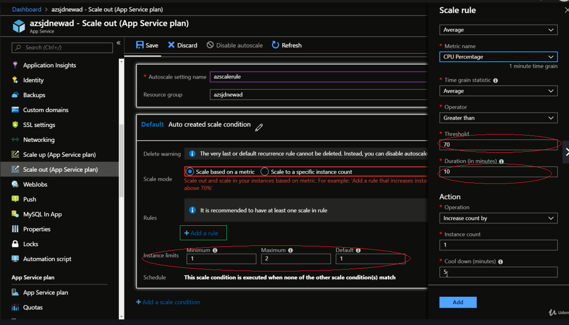

You can set instance limit 🡪 and Add new rule for scaling down

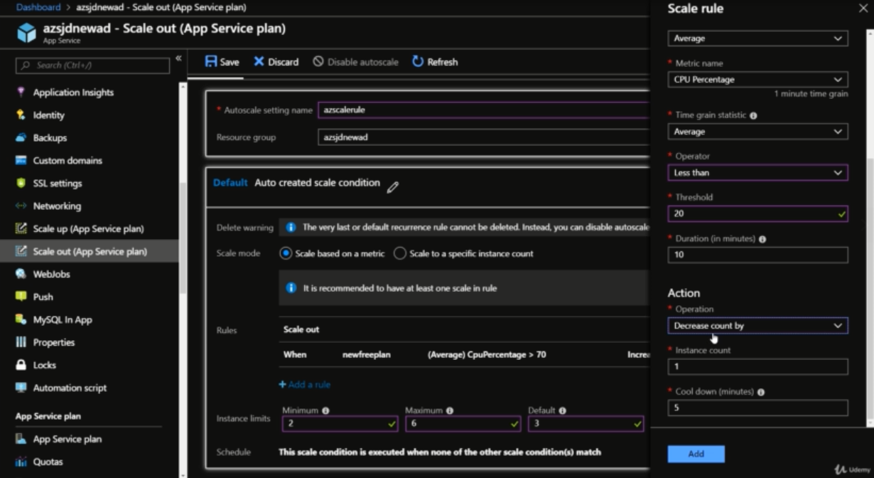

Save the configuration

You can also create more scale condition in same

* 1. **Virtual Machine Scale Sets**

If your application is running in VM as IAAS, how you scale VM?

One solution is 🡪 Virtual Machine Scale sets

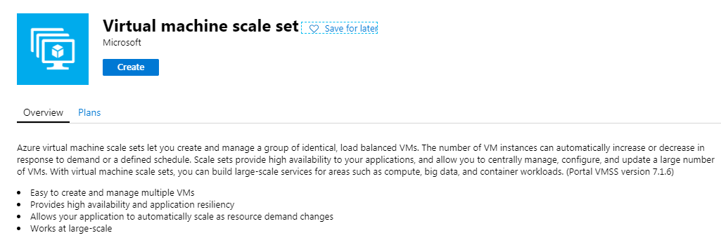

You can set the auto scaling here

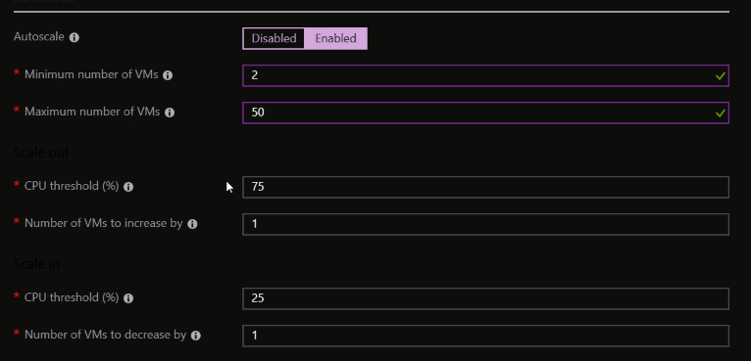

* 1. **Scaling a single virtual machine**

If you running a single VM and you found that CPU utilization is spiking, it sustained above 80%

Moving to VM size is required 🡪 go to VM 🡪 click size 🡪 you have standard selection criteria

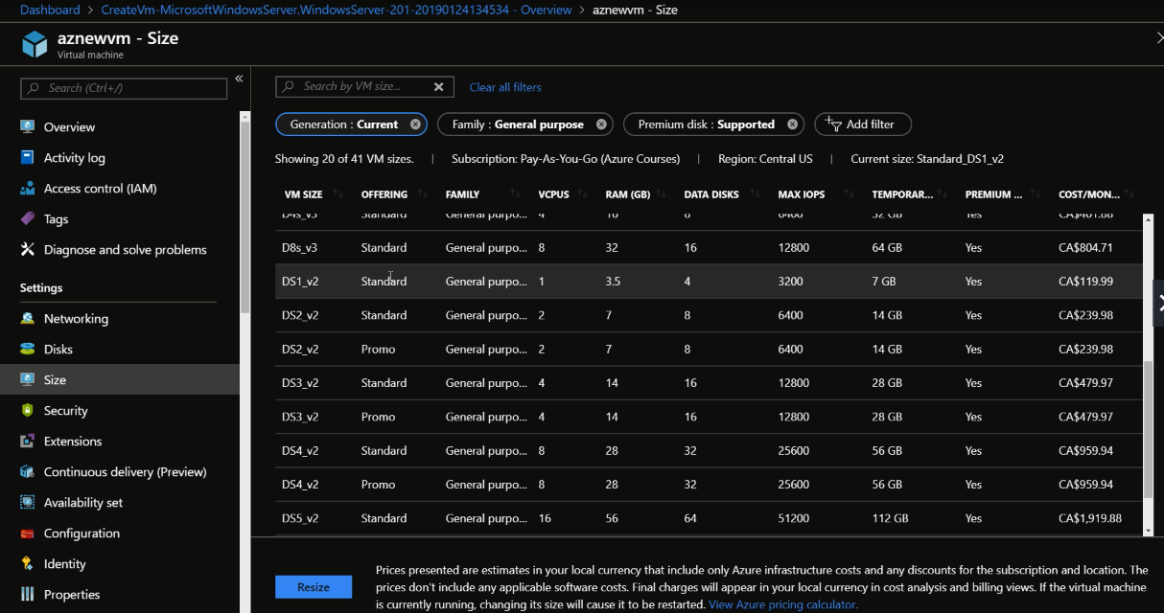

Or you can create a new VM 🡪 redirect the traffic to this VM 🡪 you can use load balancer 🡪 and redirect traffic between the VM

* 1. **Handling Transient Fault**

To prevent against failure

During scaling application may cut off during setting 🡪 so

In case of database transit 🡪 if transition fails then Retry/back-off logic, you can opt the developer process 🡪 either rollback before transition and reset the record back to process or put the rest back in the queue.

Application shouldn’t be tightly coupled application, so if one fails it should not impact other.

If any keep failing 🡪 you can use the poison queue and send it back to application

* 1. **Code Sample: Scaling App Services**

Since the AZ-203 exam will want you to scale App Services, here is a relevant Getting Started Github project:

<https://github.com/Azure-Samples/app-service-dotnet-scale-web-apps>

This code is .NET Framework. Other languages and samples are available in that repository.

1. **Az-203 Caching and Content Delivery Networks**
   1. **Introduction to Redis Caching**

Redis is open source application for caching – is an in memory caching, guarantee low level latency, not store in disk, it store in memory.

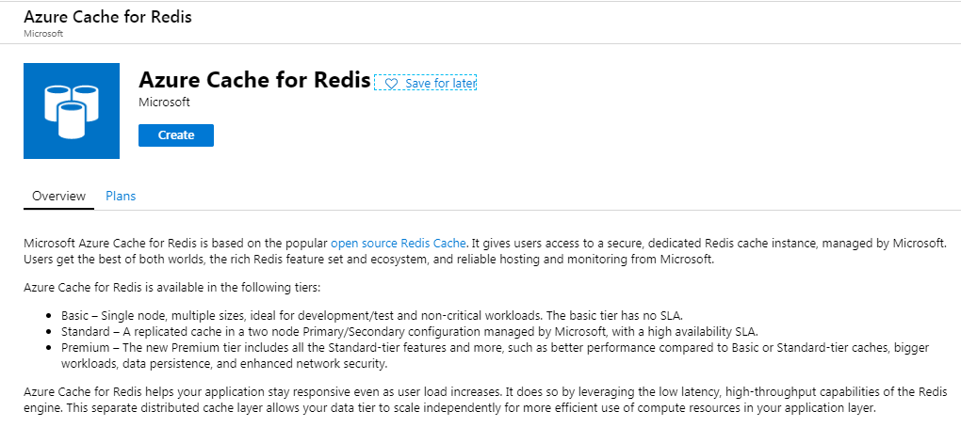

If you came back to page1, page2 or page3. It will get the data from in memory cache.

* 1. **Reading and writing to Redis in .Net**

Open Visual Studio 🡪 Create new project 🡪 Manage Nuget package 🡪 Search Redis

Select StockExchange.Redis

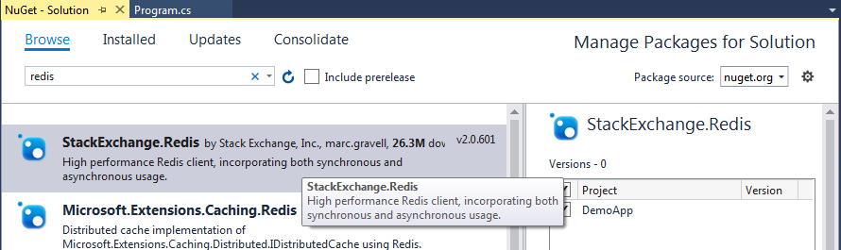

In code use 🡪 using StackExchange.redis

Get the connection string as below Green

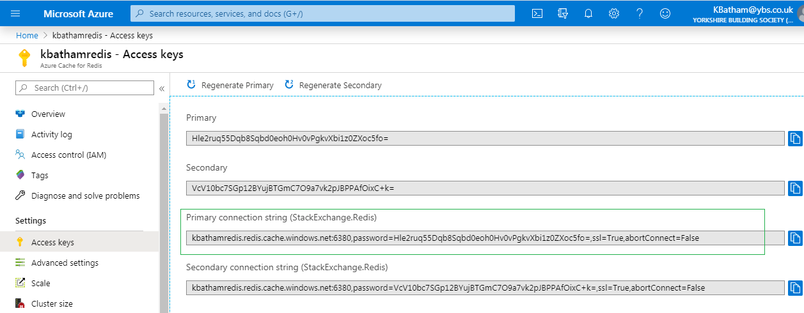

Define a static string for connectionstring

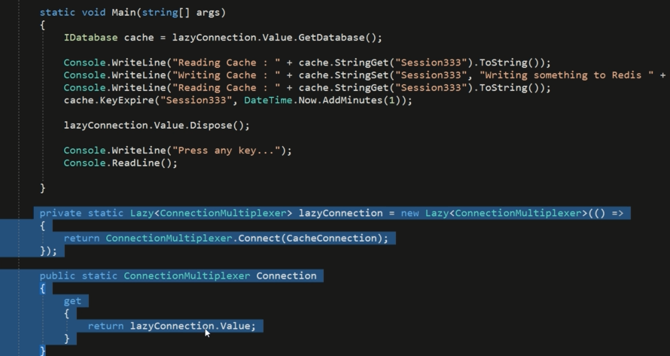

Code will store data into Session333, and every time you run, it will show cached data

* 1. **Creating CDN Profile**

Redis is backend type of cache, end user not have any idea they are using cache.

When come to front end caching – it come CDN, it take the file and store to other server, not web server where your application running.

The Azure Content Delivery Network (CDN) is designed to send audio, video, images, and other files faster and more reliably to customers using servers that are closest to the users. This dramatically increases speed and availability, resulting in significant user experience improvements.

* Better performance for your apps and services
* Global distributed network
* Highly scalable infrastructure
* Active redundancy and failover
* High reliability
* Robust security

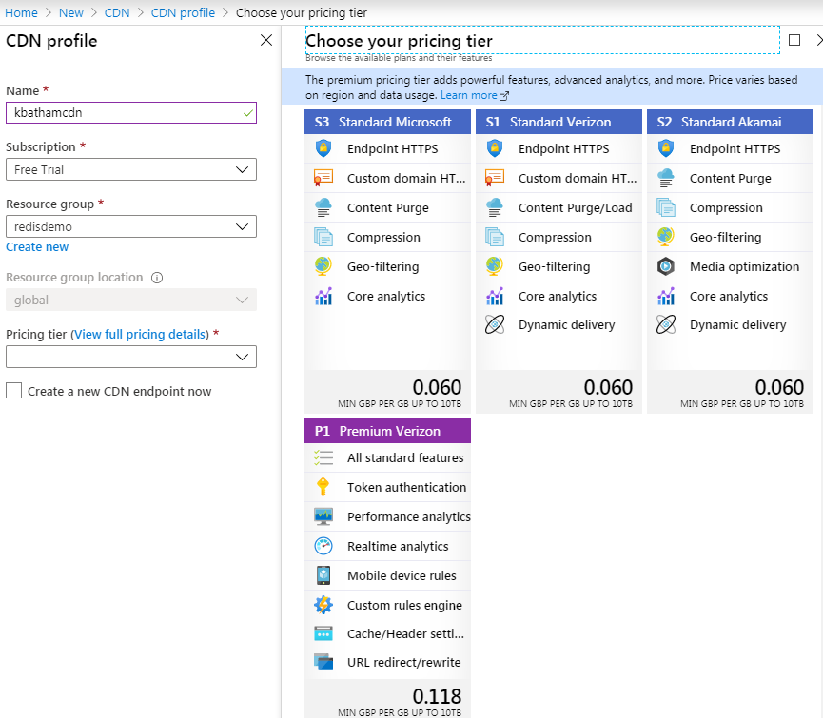

Endpoints usage by application to access the files

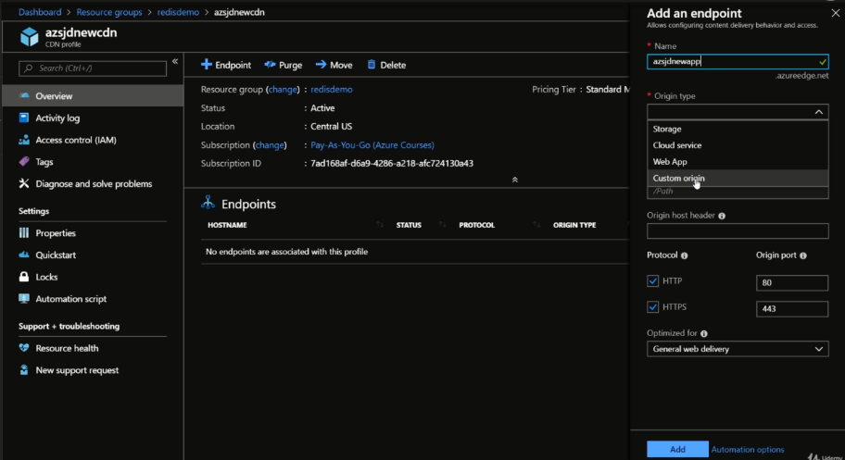

When you done with endpoint 🡪 and usage it in your application 🡪 so if somebody request endpoint for the file that is not cashed 🡪 it go server one time, request the file and store it locally 🡪 next time it will return from store location.

Problem is it cached out of the server 🡪 so how do you tell application that you got new JS file 🡪 for any new deployment

Two ways to do that 🡪 purge your CND, another is put the version number in the file name.

1. **Az-203 Monitoring and Logging**

It depends on what type of application you have deployed, whether you deployed in VM or function

* 1. **Virtual Machine Logging**